Science |  | Everyday Materials | Year 1/2
Key Vocabulary |  |   Key Knowledge and facts
word | definition | - Metals are often strong, shiny, hard and long-lasting. Metals can be hammered into different shapes.  - Wood is hard, stiff and strong and can be carved into any shape. Wood is long-lasting and is a natural product. Wood is flammable.  - Glass can be strong, but thin glass shatters. Glass is transparent and waterproof. It can be made into different shapes.  - Plastic can be tough or flexible and can be made into any shape. Plastics can be coloured or transparent. Plastic is waterproof.  - Bricks are very hard and strong. They are difficult to break. Bricks are thick and store heat well.  - Paper is often thin and can be made into lots of different shapes (flexible). Paper can be torn. It goes soggy when wet.  - Cardboard is often thin but is firmer and tougher than paper. Cardboard is more difficult to tear. It goes soggy when wet.  - Rubber is extremely tough, but also very flexible. Rubber is elastic and also waterproof. Rubber doesn’t tear easily. | We use lots of different materials every day. Some materials are used to make many things.
  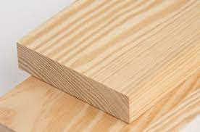  Wood  is used to build furniture, like benches and desks and used to build houses and sheds. | 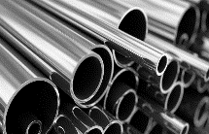  Metal can be shaped into anything, from a small paper clip to a huge aircraft.
  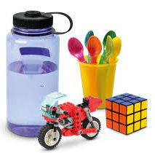  Plastic  can be used to make toys, bottles and can be moulded into plates, knives and forks. | 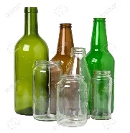  Glass  is used for windows, glasses and is also used in making mirrors
  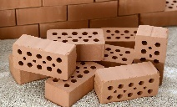  Bricks  are attached together with mortar and are used to make buildings. -They are also used for paving. | 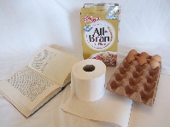  Paper is  used for writing - in diaries, notebooks and for printing on. Paper is used for posters/displays.
Absorbent | A material that is absorbent is one that soaks up liquid or moisture.
Flammable | Somerthing that is flammable easily sets on fire.
Flexible | materials that can bend easily
Material | A substance that objects are made from.
Property | This is what a material is like and how it behaves ( shiny stretchy, waterproof rigid transparent ).
Rigid | unable to bend or be forced out of shape
Transparent | an object you can see through e.g. glass
Waterproof | Water cannot pass through an object or material that is waterproof.

How can materials be changed?
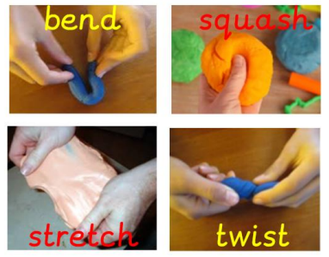

 |  | 