Science |  | Human and circulatory system | Year 6 | 
Key Vocabulary |  | Key Knowledge
word | definition | 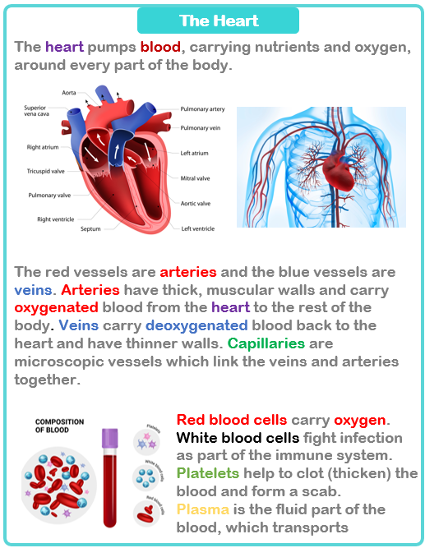  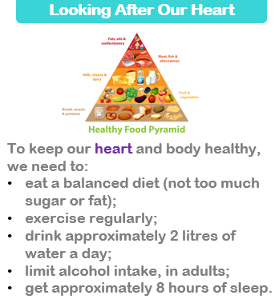
matter | Anything that has mass and volume (takes up space).
BPM | beats per minute measuring heart rate
circulatory system | the system that controls the flow of blood around the body
deoxygenated | not containing oxygen
diet | the kind of food an animal usually eats
diffusion | diffusion is the  movement of all liquids and gases
osmosis | osmosis is the movement of water only
oxygenated | containing oxygen
pulse | the rhythmical throbbing of the arteries as blood is pumped through them
valve | flaps which open and close to allow blood flow
vessel | tube which circulates the blood through the body

