History |  | Maya Civilisation | 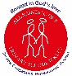  Year 6
Key Vocabulary |  | 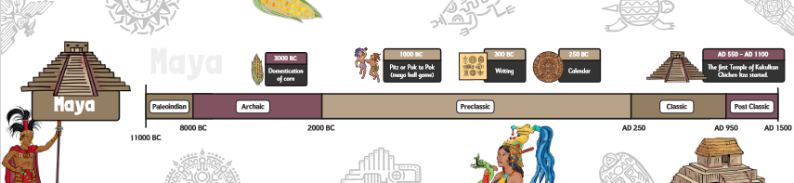
Ajaw | A Maya king/leader
Artefact | An object that is made by a person, such as a tool or a decoration, especially one that is of historical interest.
Cacao | The tree that bears cacao seeds, which are contained in large, oval pods that grow on the trunk. | Key Knowledge | Key Maps
Cacao |  | - The Maya empire was organised into city states; each city state was ruled by a different noble family.  - Maya people lived in settlements with a central temple/pyramid as a focal point.  - Maya city states traded with each other - sometimes using cacao beans as money.  - Masks were used for many purposes, but mainly funerals to protect important people in the afterlife.  - The Maya believed in and worshipped a number of different gods. They believed that the gods had a good side and a bad side and that the gods could help or hurt them.  - Priests were very important in Maya society as it was believed that they could communicate directly with the gods. | Where did the Maya live?  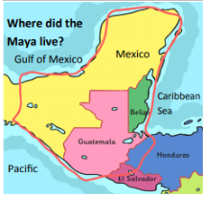  Mesoamerica – now known as Mexico - lies between the USA and South America, in a region known as Central America. It’s a long strip of land with coast on both sides; the Pacific Ocean on the west, and the Gulf of Mexico and Caribbean Sea in the east.  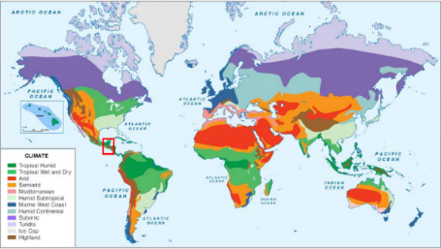  Where in the world is Central America?
Civilisation | Human society which is organised.
Empire | A group of countries ruled by a single person, government, or country.
Heptarchy | The name given to the 7 kingdoms of Anglo-Saxon England
Kingdom | A place ruled by a king, queen, or important person.
Ravine | A deep, narrow valley
Sacrifice | An act of slaughtering an animal or person as an offering to a god or gods.
Temple | A building used for the worship of a god or gods in some religions.

