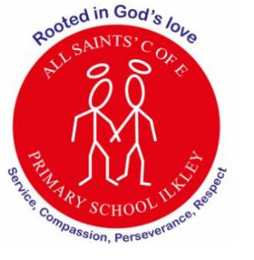
Curriculum Letter
At All Saints’ Church of England Primary School, we are rooted in God’s love, serving our
community with compassion, perseverance, and respect at the heart of everything we do.

School Values: The English text will allow our pupils to understand further the values of
compassion, respect and perseverance.
Year 5
Summer 2

Mental Health and Wellbeing  Weekly PSHE lessons, class worry boxes, class Collective Worship, outdoor play, discussion time |  | PE  Spiral curriculum based on key skills taught through a range of sports  P.E is on Tuesday and/or Thursday and swimming on Friday
English  Ernest Shackleton Expedition  - Letter writing  - Diary Writing  - Report Writing | Maths  - Decimals  - Converting units  - Volume |  | Religious Education  Creation and Science conflicting or complementary?  - Interpreting the meaning of Genesis  - Sharing interpretations of Christianity and Science  - Exploring Psalm 8  - Reflecting on our responsibility
Science: Life Cycles of Mammals  - Explore the gestation period  - Learn about foetal development  - Learn about changes experienced in puberty  - Describe changes humans may experience in old age |    |  | Geography:  Extreme environments  - Mountainous regions  - Desert (hot and cold)  - Caves  - Space  Climate and extreme weather
Computing: Creating Media  Programming B – selection and quizzes | Music:  Songwriting and digital technology |  | PSHE: Growing and Changing  - Taking notice of our feelings  - Help! I’m a teenager - get me out of here!
Art / D.T:  Gears and pulleys  - Moving toys  - Cams | French  Children will learn about Paris, how to name activities in French, and take part in simple question-and-answer conversations to build everyday language skills. |  | How parents/carers could help  - Encourage your child to regularly read  - Continue with times table practise  - Talk to your child about their daily learning  - Encourage your child to add to the class Padlet, recommending reading books.

