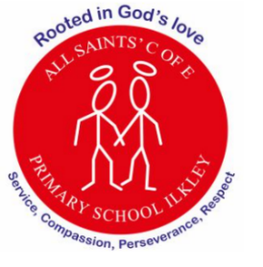
At All Saints’ Church of England Primary School, we are rooted in God’s love, serving our community with compassion, perseverance and respect at the heart of everything we do.
School Values: Inspired by the natural world and the animals we study; we learn to care for one another and our environment with compassion and respect. Just as Mary Anning showed perseverance, curiosity, and courage in her discoveries, we strive to keep going even when learning is challenging. Through our RE learning and symbols of faith, we remember that God is always with us, guiding us to serve our community with kindness and love. In PSHE, as we explore growing and changing, we learn to understand ourselves and others, building respectful relationships and valuing each person as unique and special.

Curriculum Letter
Year 1
Summer Term 2
June 2026

Mental Health and Wellbeing  Coram PSHE Lessons, outdoor play, circle time, worry boxes in classroom |  | PE  Spiral curriculum based on key skills taught through a range of sports  P.E is on Monday and Friday
- English  - Reading - Dear Dinosaur, Stone Girl Bone Girl  - Writing –, diary/letter writing about fossil discovery Mary Anning fact file – dinosaur research  - Grammar/Punctuation – recap on all learning from this year | Maths  - Recap on all bonds up to to 10  - Place value to 100 – partition, order and compare numbers from 50- 100  - Money – recognise coins – counting in 2s,5s and 10s  - Time tell time to hour /half hour |  | Religious Education  How are symbols used to welcome new life?  - Explore and talk about different ways to welcome a new baby  - How do different religions welcome a new baby  - What do names mean and why are they important?
Science  Animals, including humans  - Identify and name a variety of common animals including fish, amphibians, reptiles, birds and mammals  - Identify and name a variety of common animals that are carnivore, herbivore or omnivore | 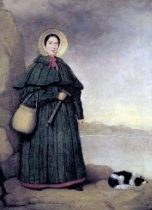  Digging for dinosaurs  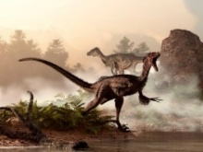 |  | Art/DT  - Create moving animals  - Observational drawings of fossils  - Create fossil pictures using a variety of materials  - Clay fossils  - Artist study – Friedensreich Hundertwaser - Spirals
History  - Mary Anning- how did she contribute to science/ palaentology  - Discovering fossils. What is a fossil?  - Dinosaur discovery | Music  BBC 10 pieces – Mars  - To create sounds for things you find in space, and make up new lyrics to a song!  - To create a space map, with sounds that go with each destination or character! |  | PSHE  - Growing and changing: Understand the importance of keeping healthy – food, sleep, exercise.  - Identify parts of the body that are private  - Secrets and surprises
 | Computing  Programming |  | How parents/carers could help  - Read with your child on a regular basis  - Fossil hunting on weekend walks!  - Use the Year 1 knowledge organisers to quiz children about the content.
Reminders  Please read with your child on a regular basis  - Reading books to be in school on Thursday ready to be changed on Friday. | Enrichment opportunities  - Sports week  - Dinosaur assembly

