Geography |  | Extreme Environments |   Year 5
Key Vocabulary |  | Key Knowledge and facts
word | definition | 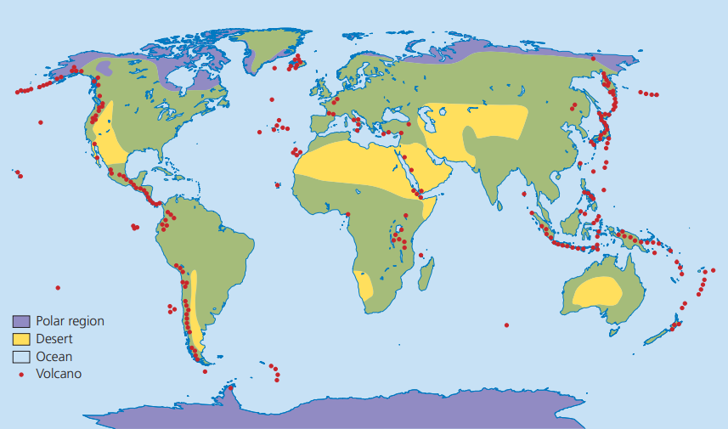  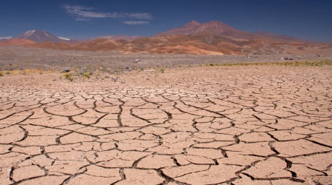  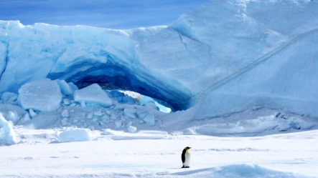  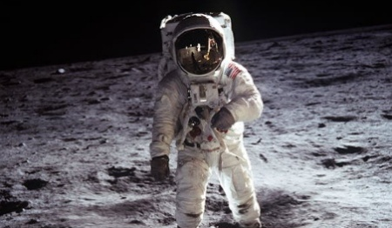  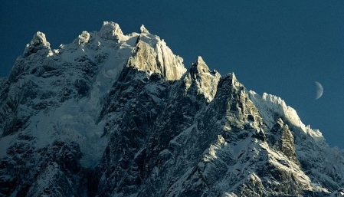  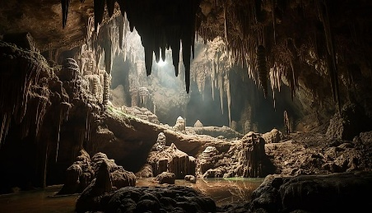  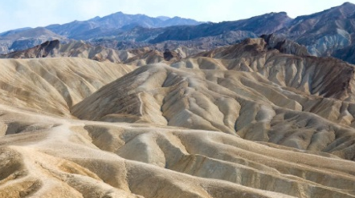  No Water  Extreme Cold  Low Air Pressure  No Natural Light  No Breathable Air  Extreme Heat  To Survive Humans Need:  ∞ Breathable Air ∞ Food ∞ Source of Natural Light  ∞ Portable Water ∞ Moderate Temperature ∞ Correct Air Pressure
Extreme environment | Places where human survival is difficult or impossible.
Climate | An area's long-term weather patterns (e.g. the average temperature in different seasons, rainfall, and sunshine.)
Biomes | Areas of the planet with similar characteristics, including climates, landscapes, animals and plants.
Topography | The physical features of an area of land.
Inhabitable | A place that can sustain life for a significant period.
Mountain | Mountains are high areas, rising more than 600 metres from the surrounding land.
Altitude | How high a place is above sea level. The higher the altitude, the colder it gets because the air is thinner.
Desert | A desert is a place that gets hardly any rainfall; deserts are incredibly dry environments.
Space | The area directly outside the Earth’s atmosphere.
Cave | A cave is a natural hollow space under the ground that has an opening large enough for a person to enter. Caves range in size from tiny passages to huge systems of connected “rooms” and tunnels.

