Science |  | Animals including humans –  All about animals | Year 1
Key Vocabulary |  |   Key Knowledge and facts
word | definition | The five animal groups  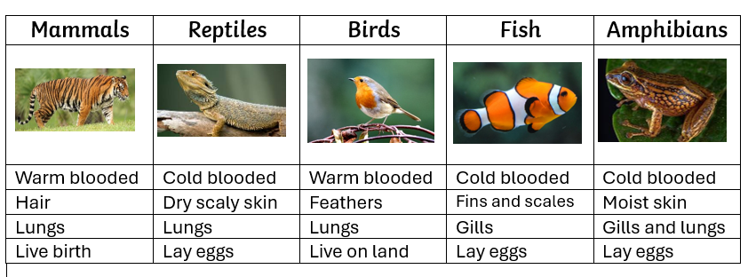  Cold blooded  Cold-blooded animals, like reptiles, amphibians, and fish, become hotter and colder, depending on the temperature outside.  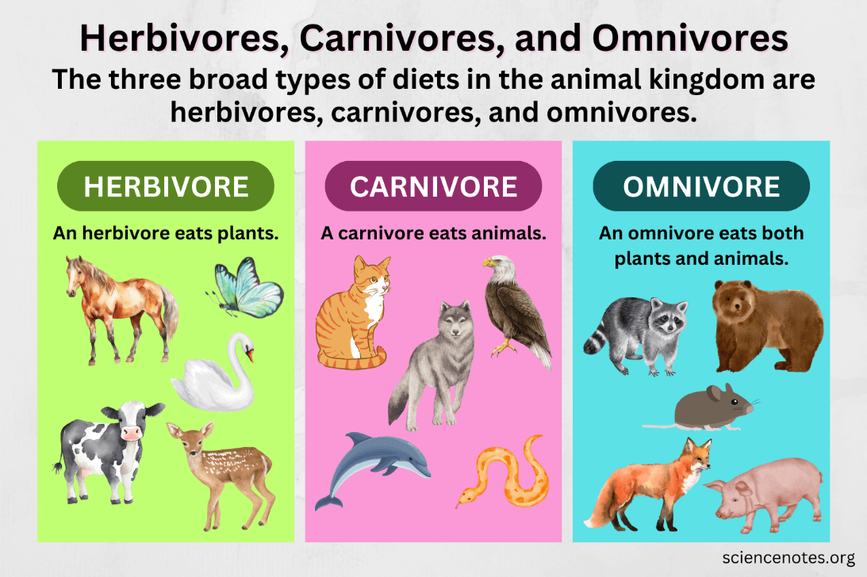  Warm blooded  Whether it is sunny and hot outside or there is a snowstorm and it is very cold, warm-blooded animals have body temperatures that usually stay the same.
Amphibian | A cold-blooded animal that spends time on land and in water.
Animal | A live species that lives on Earth
Bird | An animal with a backbone and wings and feathers.
Carnivore | An animal that only eats meat
Fish | An animal that lives in water and breathes through gills and fins for swimming.
Herbivore | An animal that only eats plants
Mammal | A warm blooded animal with a skeleton inside its body that grows fur or hair. Mother produces milk.
Omnivore | An animal that eats both plants and meat
Reptile | A cold blooded animal with skin covered with scales.  