History |  | Mary Anning |  | Year 1
Key Vocabulary |  | Key Knowledge/events and facts |  | 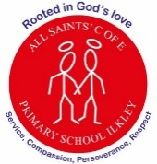  Key People
word | definition | - Mary Anning was born in 1799.  - She lived by the coast in Lyme Regis. This coast is known as the Jurassic Coast.  - Dinosaurs existed millions of years ago before humans lived on earth. They are now extinct. When they became extinct, their remains were left behind as fossils.  - Mary collected fossils on the beach as a child which she called curiosities.  - Her father taught her how to get fossils out of the rock using a hammer and a chisel.  - As an adult, Mary made many important fossil discoveries which changed what we know about the world today.  - She found a giant fossil that no one had seen before. It was a giant creature called an Ichthyosaurus.  - The men of science who came to see her discoveries did not give Mary any credit for what she found as she was a woman and poor. | 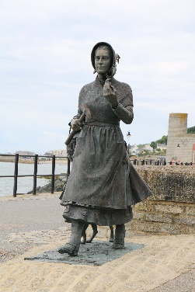  Mary Anning  Celebrated as one of the greatest fossil hunters.  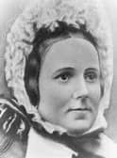  Elizabeth Philpott.  A fossil collector who taught Mary about fossils.
dinosaurs | A species of animal that roamed the earth over 65 million years ago
discovery | If someone make a discovery they are the first person to find or become aware of something that no one knew before.
evidence | Information which proves something is true.
extinct | A species that no longer exists
fossil | The remains for a plant or animal embedded in rock.
jurassic | A period of time when some dinosaurs lived.
paeleontologist | A scientist who studies fossils. | 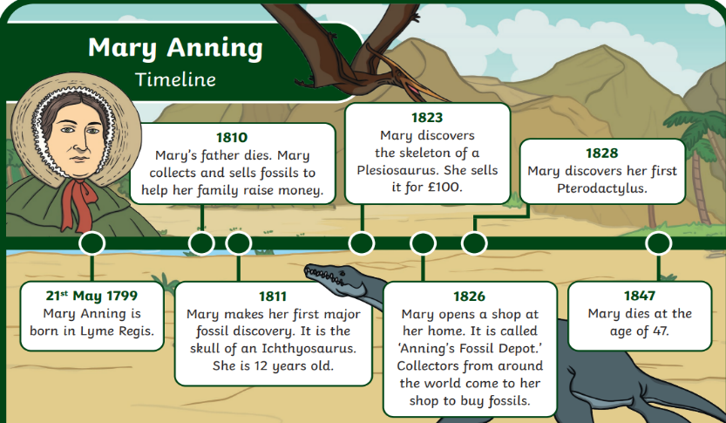  Mary Anning Timeline  