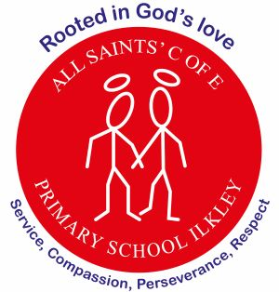
At All Saints’ Church of England Primary School, we are rooted in God’s love, serving our community with compassion, perseverance, and respect at the heart of everything we do.
Focus: Love – showing love towards others and appreciating everyone’s differences
Perseverance – not giving up when works becomes challenging
Curriculum Letter
Year 6
Summer term 1

Mental Health and Wellbeing  5-minute daily well-being class exercises  Coram PSHE Lessons, outdoor play, worry boxes in classroom |  | PE  Spiral curriculum based on key skills taught through a range of sports  P.E is on Monday and Friday
English  Reading – New class book to enjoy. A selection of texts for guided reading, animations  Writing – narrative and dialogue, flashbacks, alternative endings  Grammar focus – Mixed grammar focus recapping and consolidating learning | Maths  Shape – Angles, circumference and 3D shapes  Consolidation of prior learning |  | Religious Education – Why are some journeys and places special?  Thinking about pilgrimages and spiritual journeys as well as metaphorical journeys through faith.
Science – Classifications – Living things and their habitats  Understanding that living things are grouped by observable features. Plants, animals, and micro-organisms are classified by their similarities, differences, and specific characteristics. | French  Days of the week, Numbers – up to 70, clothing, weather, describing yourself |  | PSHE – Being my best  Looking at health and wellbeing, assessing risk and keeping safe, and basic first aid.
Geography – Coasts  Investigate what coasts are, how they are formed, how they are protected and why they are constantly changing. Study the processes of erosion and deposition and how they affect the coast. | Music – Earth (BBC 10 Pieces)  Ukulele continued, then exploring a piece of music and creating a class composition |  | Art – Environmental Art  3D modelling, using recycled materials, looking at how plastic affects our oceans.
 | Computing – Website creation  Looking back on residential memories. |  | How parents/carers could help  Read with your child on a regular basis  Encourage positive routines  Support with home learning  Develop independence to be organised for each day  Help to expand your child’s vocabulary within everyday conversation  Practice times table fluency
Homework/Revision overview  Reading: daily practice  Dictation and new spellings: Monday  Maths and English – Independent practice using revision guides to support areas for development.  Computing – becoming more familiar with touch-typing. | Enrichment opportunities  - Residential  - Post-SAT’s celebration day  - Brownlee Triathlon (19.5.26)  - Stars event at the Kings Hall (20.5.26)

