Science |  | Plants |   Year 1
Key Vocabulary |  | Key Knowledge and facts
word | definition | 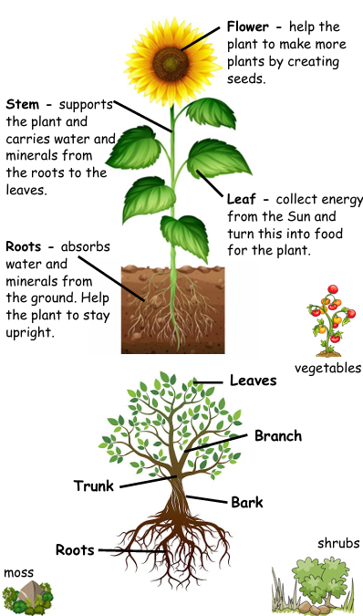 | 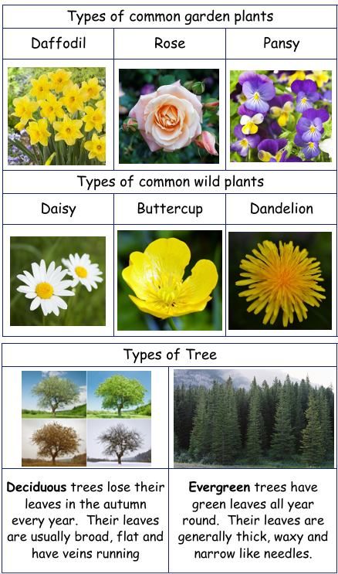
branch | The part of the tree which grows out from the trunk.
deciduous | Trees that drop their leaves.
evergreen | Trees that keep their leaves all year round.
fruit | Part of a plant that has seeds.
petal | A petal is the coloured part of the flower.
plant | A living things that has roots, a stem or trunk and leaves.
roots | Part of plant which holds it still and absorbs water.
seed | The small part of the plant which grows a new plant.
stem | The part of the plant which supports the flower.
trunk | The part of a tree which supports the branches. | 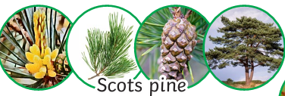  Fir  Pine  Holly  Oak  Sycamore  Horse Chestnut
vegetable | The part of the plant that can be eaten.
 | 