Geography |  | Food Glorious Food | Year 1
Key Vocabulary |  | Key Knowledge and facts | 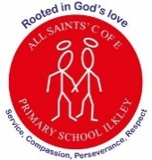  Key Maps
word | definition | 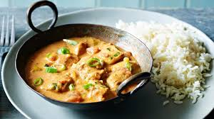  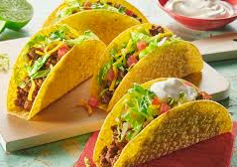  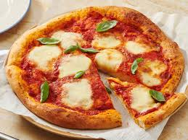  Each country has food that is traditional to them.  England – Fish and chips  Scotland – Haggis  Wales – Welsh cakes  Ireland – Irish stew  Italy – Pasta/Pizza  Spain – Paella  India – Curry  Mexico – Tacos  The UK is in Europe. The other continents are: - Africa, Asia, North America, South America, Oceania and Antarctica.  There are 4 countries that make up the U.K – England, Scotland, Wales and Northern Ireland. | 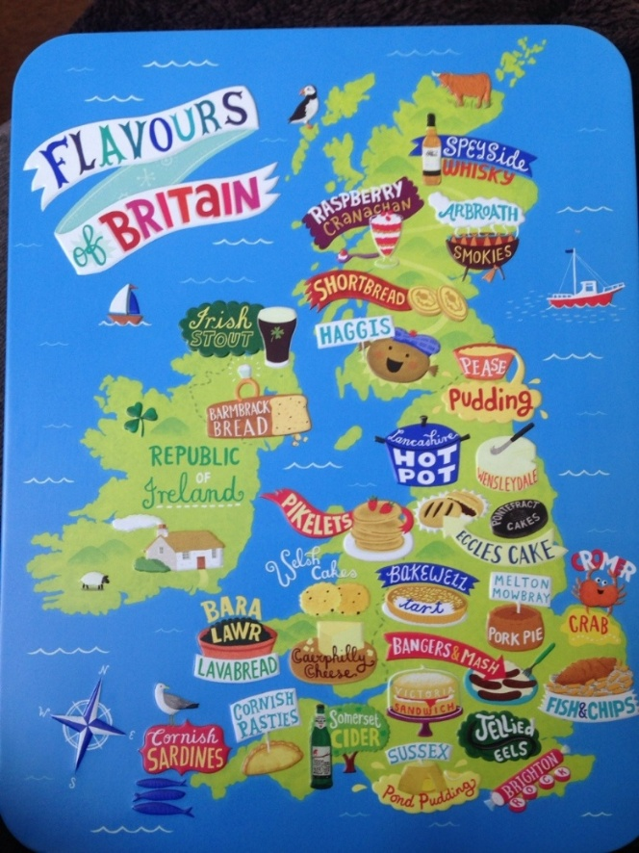  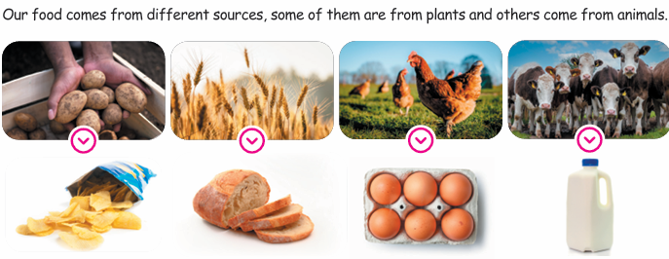  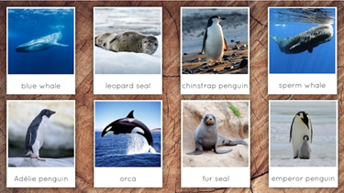
Climate | The weather in a place over time
Continent | A continent is a large solid area of land.
Crops | A plant that is grown by farmers  (e.g. wheat, potatoes)
Export | To sell products to another country
Harvest | The gathering of a crop
Import | Products brought in from another country
Traditional | Traditional refers to customs, beliefs or stories that have been passed down from generation to generation
Vegetation | All the plant life covering an area
