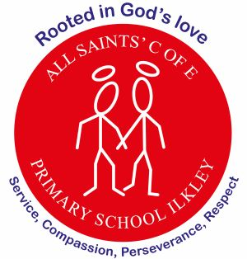
At All Saints’ Church of England Primary School, we are rooted in God’s love, serving our community with compassion, perseverance, and respect at the heart of everything we do.
Focus:
Compassion – looking out for one another and showing teamwork, in particular: around our environment.
Perseverance – not giving up when works becomes challenging.
Curriculum Letter
Year 6
Spring term 2
February 2026

Mental Health and Wellbeing  5-minute daily well-being class exercises  Coram PSHE Lessons, outdoor play, worry boxes in classroom |  | PE  Spiral curriculum based on key skills taught through a range of sports  P.E is on Monday and Friday
English  Reading – Floodland, author in focus books  Writing – Setting descriptions, alternative endings and writing formally using subjunction  Grammar focus – Colons and semi-colons, subjunctive form and verb forms | Maths  Decimals, fractions and percentages  Area, perimeter & volume – calculating the area and perimeter of triangles & parallelograms  Statistics – Line graphs, bar charts, pie charts and calculating the mean |  | Religious Education – What is the significance of Easter, Ascension and the Pentecost?  Exploring the significance of Easter, the Ascension, and Pentecost as key Christian events that celebrate Jesus’ resurrection, his return to heaven, and the coming of the Holy Spirit, showing how they shape Christian beliefs and practices today.
Science – Looking after our Environment  Children will look at climate change and the impact this has on habitats. They will then work together to think of new initiatives in regards to looking after our environment, making links to the local community. | French  Numbers to 60, family members and question and answer. |  | PSHE – Rights and Respect  This unit helps pupils understand their rights and responsibilities, how to show respect for themselves and others, and how their choices can positively impact their community and wider world.
Geography – Geographical information systems  Children will use digital mapping tools to explore Buckden and its surroundings. They will analyse how land use has changed over time, understand reasons for change, and present their findings using maps, graphs, and presentations. | Music  Children to gain further understanding of reading tab music and playing the ukulele (Whole-Class Ensemble Tuition). Whole class singing techniques – Bradford Prom |  | Art – Batik  Learning drawing and shading techniques to replicate images of animals. Children will also learn how to create art in the form of Batik, using hot wax.
 | Computing  - Introduction to spreadsheets |  | How parents/carers could help  Read with your child on a regular basis  Encourage positive routines  Support with homework  Develop independence to be organised for each day  Help to expand your child’s vocabulary within every day conversation
Homework overview  Reading: daily practice  Dictation and new spellings: Monday  Maths– Regular times table practice e.g on TTRS | Enrichment opportunities / visits  - Bradford Schools Prom

