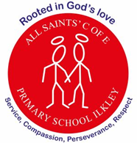
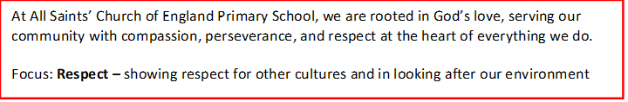
Curriculum Letter
Year 4
Spring 2
January 2026

Mental Health and Wellbeing  Coram lessons, brain breaks, mindfulness tasks, increased outdoor learning, worry boxes. |  | PE  Tuesdays and Thursdays: Spiral curriculum based on key skills taught through a range of sports.
English  Fiction:  The Tunnel  Non-Fiction:  Haiku and Limericks (Poetry) | Maths  - Fractions and decimals continued – improper fractions, adding and subtraction fractions; tenths and hundredths  - Decimals – Tenths and hundredths as fractions and decimals, divide a 1 digit or 2 digit number by 10 and 100 |  | Religious Education  - Why do the lives of Gurus inspire Sikhs?  - The first Guru and respective following  - The founding of Sikhism
Science  - States of Matter – Investigating solids, liquids and gases and how materials can change state with variable temperatures. | Ancient Eygpt  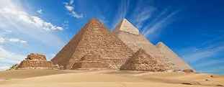 |  | PSHE  - Rights and Responsibilities
ART
- Studying Egyptian art – concentrating on the human figure, side profiles.
History  - An overview of ancient civilisations and an in-depth study of the Ancient Egyptians and their achievements | Music  - Let’s Play - Recorder |  | Computing  - Data Logging – collecting and analyzing data
Home Project Ideas  - Collage of an Egyptian face using any materials  - Make your own Shaduf  - Create a DIY lava lamp with a plastic bottle, oil and coloured water  - Creating Oobleck (Non- Newtonian fluid) with cornflour | Enrichment opportunities  Ilkley Schools Singing Together event at the Kings Hall as part of Wharfedale Festival of Performing Arts |  | How parents/carers can help  - Continue to read with your child on a regular basis.  - Play games to help with the learning of spellings e.g. hangman, scrabble, boggle, word searches etc.  - Encourage your child to use TTRS.  - Support your child with telling the time.

