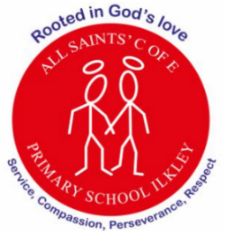
At All Saints’ Church of England Primary School, we are rooted in God’s love, serving our community with compassion, perseverance and respect at the heart of everything we do.
School Values: PSHE and RE this term focuses on learning about compassion and respect for each other and property. DT will allow our pupils to understand further the values of perseverance in the challenge of bridge building.
Curriculum Letter
Year 1
Spring term 2
February 2026

Mental Health and Wellbeing  PSHE Lessons, outdoor play, circle time and discussion time |  | PE  Spiral curriculum based on key skills taught through a range of sports  P.E is on Monday and Friday
English  - Phonics –continue with phase 5 alternative digraphs, and split digraphs and alternative pronunciations  - Fiction – Katie in London  - Non-Fiction - researching facts about London  - Writing – to create an information leaflet about London landmarks | Maths  - Place value within 50 - order and compare numbers  - Grouping and portioning into tens and ones  - Find one more/ one less using numbers to 50  - Comparing length and height  - Measure in objects then centimetres  - Explore mass and volume |  | Religious Education  What do Christians Believe God is like?  - Reflect on own beliefs – what do they believe in? Do others believe the same?  - To begin to express their own ideas about God.  - To begin to show awareness that different people see God in different ways.  - To understand what a parable is.
Science - Exploring Everyday materials 2  - Explore the properties of everyday materials.  - Investigate the suitability of different materials for specific purposes.  - Children will design and build a structure strong enough to withstand wind.  - Test materials to explore how they repel water. | 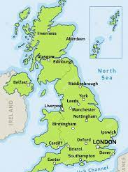  What is it Like where we live?  We Are Britain |  | PSHE  Rights and Responsibilities  - Recognise how a person's behaviour (including their own) can affect other people.  - Develop their sense of respect for objects - including things in the environment.  - To understand why first aid is important.
Geography - Where I Live - We are Britain  - Use maps, atlases and globes to name and locate the four countries and capital cities of the UK and the surrounding Seas  - Recognise the different human and physical features found within Ilkley and the four countries.  - Use simple compass directions | Music  - Weather – Look at the work of Vivaldi’s Four Season in preparation for composing their own music. Children to think about which instruments will create the best effect for that weather type. |  | Art/ D.T  - Art - To look at the work of Friedensreich Hundertwaser especially his love of spirals  - DT - Look at bridges as structures (link to work on Ilkley). Compare famous UK bridge designs.  - Design and make a bridge.
Computing
- Sorting objects into groups and explaining choices.
- Using simple digital tools to represent data.
Reminders  Please read with your child on a regular basis  Reading books to be in school on Thursday ready to be changed on Friday. Each child will receive two books on this day. | Enrichment opportunities  - Walk to the river in Ilkley to sketch the old bridge and the new bridge in preparation for their DT work on bridges. |  | How parents/carers could help  - Encourage your child to use Numbots.  - Use the Year 1 knowledge organisers to quiz children about the content.  - Send in pictures of children visiting a bridge.

