



Vision

Rooted in God’s love, we serve our community with compassion, perseverance and respect.

Values

At All Saints’ Church of England Primary School, we are rooted in God’s love, serving our community with compassion, perseverance, and respect at the heart of everything we do.

Special Educational Needs and Disabilities Information Report 2025

Written: Megan Jeffery, SENDCo

Updated: October 2025

Presentation date: October 2025

Reviewed by: Mrs. Caroline Falconer

Review due date: October 2026

All mainstream schools and maintained nursery schools are required by law to produce an annual SEND Information Report: Special Educational Needs (Information) Regulations Clause 65. This information report covers the relevant points detailed in the SEND Code of Practice (Section 4.34 -4.36 and 6.79 – 6.83).

TYPE OF SCHOOL: Mainstream - Primary, KS1 and KS2

ACCESSIBILITY | Fully Wheelchair Accessible | Yes
 | Adaptations: sensory and physical  (Including  Sensory enhancements) | - Rainbow room  - Sensory room  - Coloured overlays  - Coloured books/printing  - Smart whiteboards/typeface  - Laptops with speech recognition software  - Fidget toys  - Mini trampoline  - Easy Access Toilet  - Hoist  - Shower
CORE OFFER | Are you currently able to deliver the ‘Core offer’ as set out in Bradford’s Local Offer? | Yes  https://localoffer.bradford.gov.uk/kb5/bradford/directory/home.page  http://www.kent.gov.uk/education-and-children/special-educational-needs
POLICIES | Are the school policies available on its website for: | SEND | Yes
POLICIES | Are the school policies available on its website for: | CHILD PROTECTION AND SAFEGUARDING | Yes
POLICIES | Are the school policies available on its website for: | POSITIVE BEHAVIOUR POLICY | Yes
POLICIES | Are the school policies available on its website for: | EQUALITY OBJECTIVES | Yes
POLICIES | Are the school policies available on its website for: | SUPPORTING CHILDREN WITH MEDICAL CONDITIONS | Yes
POLICIES | Are the school policies available on its website for: | ACCESSABILITY | Yes
POLICIES | Are the school policies available on its website for: | Positive Relationships (ANTI-BULLYING) POLICY | Yes
POLICIES | Are the school policies available on its website for: | COMPLAINTS POLICY | Yes
POLICIES | Are the school policies available on its website for: | ADMISSIONS | Yes
POLICIES | Are the school policies available on its website for: | ATTENDANCE | Yes
POLICIES | Are the school policies available on its website for: | RISK ASSESSMENT | Yes
POLICIES | Are the school policies available on its website for: | EARLY YEARS | Yes
 |  | RELATIONSHIPS, SEX AND HEALTH EDUCATION POLICY | Yes

DISABILITY LEGISLATION | Are you aware/familiar with the requirements of the Disability Discrimination Act 1995 and the Equality Act 2010 | Yes

RANGE OF PROVISION
Please indicate what your school has to offer (over and above your core offer)
In each of the following areas:
Areas of strength
- All Saints’ C of E Primary School is proud of its inclusive learning environment and the opportunities that it provides for all of its pupils
- We have a modern building situated over two floors with a lift. We also benefit from having a Forest School, Rainbow room and sensory room, with fully trained staff.
- We have a range of staff who bring with them different qualities and expertise.
- We offer lunchtime support during unstructured times including a supported playground.
- The needs of our children are at the centre of all decisions made by the senior leadership team.
- Parents and carers are involved in decisions made about provision for their children who have SEN. This is communicated and reviewed with parents 3 times a year during parent-teacher meetings.
- Early identification of need can be assessed through the RAPID and LASS assessments to identify early signs of potential dyslexia. This supports with ensuring classroom provision is right for every child.
- Staff have regular in-house training to support a wide range of additional needs in the most effective ways possible. They attend training in order to ensure up-to-date thinking and create an environment that offers the best opportunities for our pupils. Best practice is shared between staff and other settings including through the 2VLC SENCo group. The SENCo also regularly attends the local authorities SEND group led by Educational Psychologists.
- Children are all able to actively take part in sensory circuits as part of whole class regulation strategies or throughout lessons for those that may find the classroom environment challenging.
- Older pupils in school volunteer to support other pupils in school to develop their social, emotional and play progression providing a mutually beneficial development step.
- Progress and positive behaviour for learning are celebrated in school Collective Worships with a certificate of achievement. Parents are invited to school Collective Worships to celebrate the learning and achievement of their children. For some children, individual rewards, including activities based around personal interests, are used as a motivational tool to support behaviour for learning and attention in tasks.
- All classrooms use visual timetables and visual aids to support transitions and access to the curriculum.
- The school promotes communication friendly environments such as low stimulus colours on display to support children’s ability to regulate. There are also resources provided in each classroom to support with sensory needs such as wobble cushions, resistance bands and fidget toys.

Input from Educational Psychologist/Therapists/Advisory Teachers/other speciality support services
When appropriate, children can be referred to a range of external agencies to receive the best possible support to cope with their individual needs. These may include:

- Speech and Language Therapy (NHS)
- Outreach Services
- Community Paediatrician
- School Nurse
- CAMHS
- EEWP (education emotional wellbeing practitioners)
- Educational psychologists commissioned from the Bradford EP department
- Specialist Teaching Service (SCIL)
- Family Support Courses
- Occupational Therapist
- Early Help
- Social prescriber (Support from the local surgeries)

Morning and after school activities:

- Breakfast Club available Mon – Fri from 7.30am to 8.45am
- After school Club from 3.20pm to 6.00pm
- Enrichment clubs run throughout the year and are available to all children.

Inclusion

At All Saints’ we aim to support all children with their individual needs. We are able to provide a wide range of SEND support. Examples include support for: Speech, Language and Communication Difficulties; Literacy and Numeracy difficulties; Global Developmental Delay (GDD); Autism; Attention Deficit Hyperactivity Disorder (ADHD); Medical and physical needs; social and emotional needs; Dyslexia and Dyscalculia.

We employ a specialist HLTA for Speech and Language support, Mrs. Gill Sangster who provides interventions informed and directed by NHS Speech and Language Teams.

We have a range of assessment resources to support identification of need, including RAPID and LASS assessments.
The school’s policy for all pupils identified as SEND, including pupils who do, and do not have an EHC Plan, can be found here.

This policy outlines how All Saints C of E Primary School evaluates and assesses what level of support may be required for an individual child. It also highlights which members of staff support the child through each stage.

A child identified as having special educational needs and/or disabilities will be placed on the monitoring list or SEND Register, dependent on level of need, and depending on the level and complexity of support required, we will work with the family and child to plan their support using a personalised provision plan.

This is a document which defines what provision is being made to meet an individual’s needs and is used to share targets, evaluate performance, and to demonstrate that school are working in partnership to ensure a child’s needs are met.

Monitoring

As a school we employ the graduated approach, to assess and plan for children identified as needing support, and arrange the additional or different provision required to enable children to make expected progress, or above. This additional provision is continually reviewed to ensure it is effective in improving children’s outcomes following the assess, plan, do and review cycles. A Provision Map may be devised if it is necessary to plan interventions and set targets in addition to, or different from the rest of the class. The Provision Map may suggest alternative strategies, learning programs, modifications to the curriculum and/or extra support for the child, individually or in small groups. SMART targets with entry and exit data are set with a date for review at least 3 times a year with pupil and parent voice captured during this time. These are overseen by the school SENCo who will support teachers in implementing correct provision to meet the child’s needs. The class teacher makes appropriate arrangements for differentiating the curriculum and providing additional support for the child as part of QFT and ensures this is communicated to new teachers during transition meetings.

Approach to teaching and support

The school’s approach to meeting the needs of pupils with SEND (including pupils who do and do not have an EHC Plan) always starts with quality first teaching which is flexible and inclusive. As a guide, the Mainstream Core Standards set out in Bradford’s Matrix of Needs which define expectations for quality first teaching.

Where children are identified as needing additional or different support to make progress, we employ the graduated response as detailed above, and will tailor teaching and learning to better support the child, using advice, as appropriate, from external agencies which is part of our graduated approach.

What proportion of children at the school are on the SEND register | 9.1%
Percentage of children with an Education, Health and Care Plan (EHCP) | 2.12%
Parent support and involvement

Parents and carers play an essential role and are encouraged to build positive relationships with the school. Parents and carers will be updated on any changes to targets and interventions or any concerns around the progress their child is making. We encourage parents to share feedback with school and there is the opportunity for this to be captured within the child’s provision plan reviews. Parents are also able to email any feedback to the school.

Parents and carers are also encouraged to speak to the class teacher as a first point of contact, should they have any concerns about their child and their learning needs. All Saints’ C of E Primary School’s SENDCo is Miss Megan Jeffery. A member of staff will be on the gate in the mornings and after school should a parent wish to speak to them to raise any concerns to do with their child. Alternatively, an appointment can be made by contacting the school office or emailing sendco@allsaintsilkley.bradford.sch.uk

Here is a simple flowchart to guide you on who to contact in the first instance:
This flowchart is designed to help parents of children with SEND know when to contact the class teacher and when to contact the SENCo. Please note that there are four areas that fall under SEN support which include cognition and learning; communication and interaction; social, emotional and mental health; and physical and sensory. Your child does not need to have a diagnosis in order to access SEN support in school. Support is sometimes needed in the short term, and for other children longer term support may be needed to help them thrive.
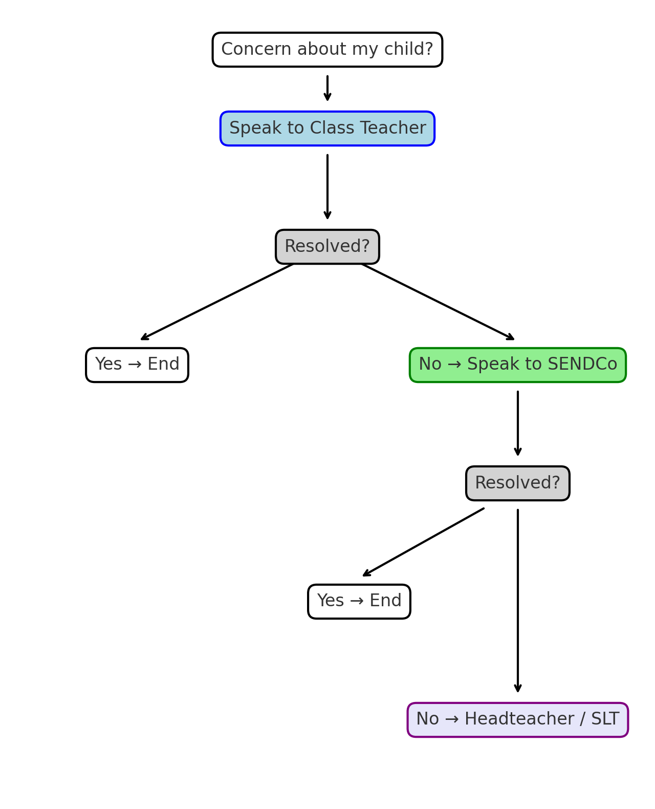

Involvement of children and young people

The code of practice clearly states that children must play an active role in their education. Wherever possible children are actively involved in planning for their next steps in learning. This will be through smart targets that they are working towards, and are reviewed regularly. Children will be given the opportunity to discuss the interventions they are receiving and how they feel they are progressing. Child voice will be actively sought to identify how children feel they work best, and what would enable them to work better. Where necessary, this will be scaffolded using visual prompts including pictures and photographs to enable children with significant communication and learning needs.

Evaluating SEND provision

Children’s progress is reviewed each term. This is done by the Class Teachers, by the SENDCo and by the Leadership Team. If it is deemed that additional support is needed, this will be planned cohesively and monitored by the SENDCo for its effectiveness. The Provision Maps created for children who require additional support for their learning, track interventions and the contribution they make towards accelerating progress. Regular reviews of the Provision Maps ensure that the package of support provided for children with additional need is the best possible available and is adapting to the child’s changing needs over time. The SEND Support register is also updated regularly to reflect these changing needs.

SENCO contact details

Name of SENDCo: Miss Megan Jeffery
Contact Details: 01943 607852
SENDCO@allsaintsilkley.bradford.sch.uk

Concerns and complaints

Please feel free to come and discuss any concerns you have regarding the provision in school for your child with the class teacher or the SENDCo. If you do not feel that your concern has been dealt with correctly, please arrange a meeting with the Headteacher.
Name: Mrs Dunn
Email: office@allsaintsilkley.bradford.sch.uk
Tel: 01943 607852
The school’s Complaints policy can be found here.

COMPLETED BY | Miss Megan Jeffery – SENDCo
DATE COMPLETED | October 2025
UPDATED

