Science |  |  | Everyday Materials (2) |   Year 1
Key Vocabulary |  |  | Key Knowledge and facts
word |  | definition | 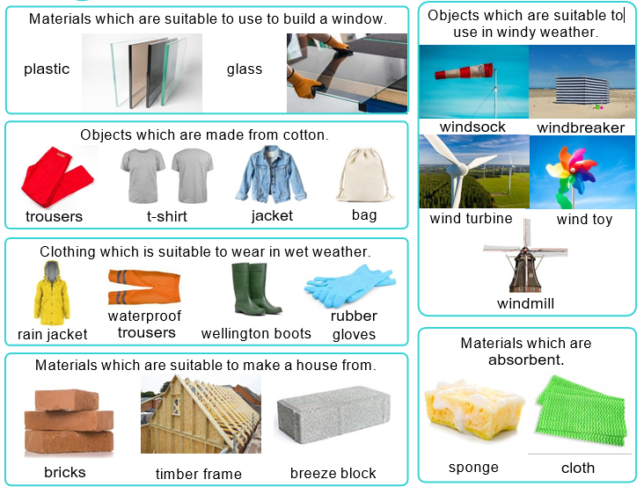
absorbent | a material that soaks up water
brick | a hard material that is used to build walls
clay | a natural material found in the ground
cotton | a type of soft fabric which is often used to make clothes
Flexible | materials that can bend easily
material | what something is made from.
opaque | does not allow any light to travel through
rigid | unable to bend or be forced out of shape
slate | a natural material found in the ground - used to build roofs
strong | not easy to break
transparent | allows light to travel through
waterproof | something that keep out water

