Geography |  | 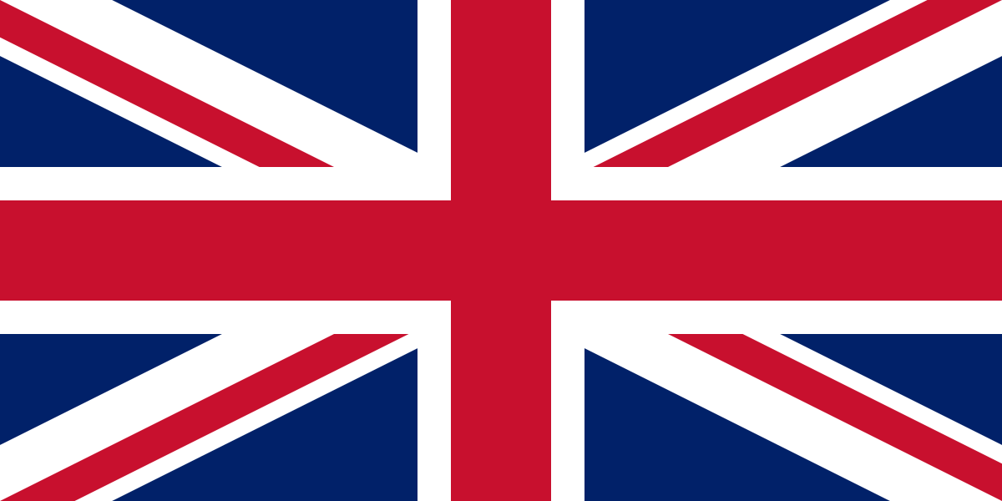  What is it like where we live? (We are Britain) |  | Year 1
Key Vocabulary |  | 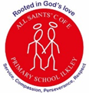  Key Knowledge and facts
word | definition | - The United Kingdom is made up of four countries; England, Scotland, Northern Ireland and Wales.  - Ilkley is a town in England, in the United Kingdom.  - Ilkley has a river that runs through it called the River Wharfe.  - The capital city of England is London.  - The capital city of Wales is Cardiff.  - The capital city of Scotland is Edinburgh.  - The capital city of Northern Ireland is Belfast.  - There are four seas that surround the United Kingdom; English Channel, North Sea, Irish Sea and the Atlantic Ocean. |  | 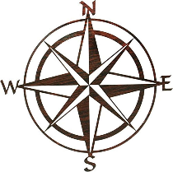        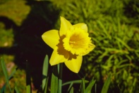  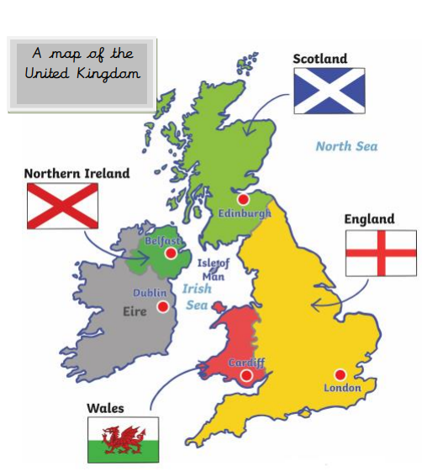  Irish  Sea  North Sea  Atlantic Ocean  English Channel  Compass
Capital city | A capital is a city where a region's government is located.
City | A city is a place where many people live closely together usually containing a cathedral.
Compass | A tool for finding direction.
Human Features | Features made by humans (city, village, farm, factory, house shop).
Map | A drawing of all or parts of the Earth and shows where things are.
Physical features | Natural features on the Earth's surface (river, hill, mountain)
Sea | A sea is a large body of salt water partially enclosed by land.
Town | A place with many streets and buildings where people live and work.
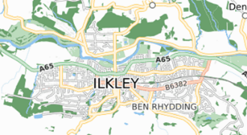
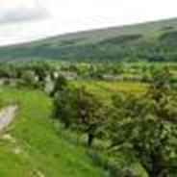

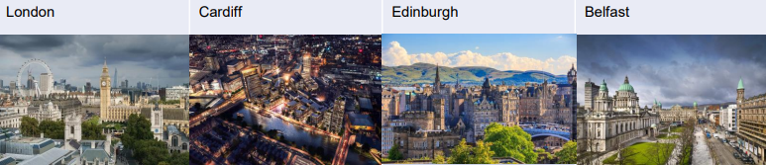 |  |  | Physical Features |  | Human Features
 |  |  | 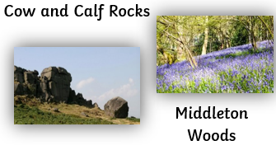 |  | 