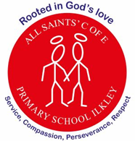
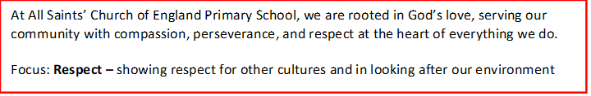
Curriculum Letter
Year 4
Spring 1
January 2026

Mental Health and Wellbeing  Coram lessons, brain breaks, mindfulness tasks, increased outdoor learning, worry boxes. |  | PE  Tuesdays and Thursdays: Spiral curriculum based on key skills taught through a range of sports.
English  Fiction:  Marcy and the Riddle of The Sphinx (Legends)  Narrative, dialogue and punctuating speech focus  Non-Fiction:  How to Mummify an Egyptian Body (Instructional Text)  Writing instructions | Maths  - Multiplication and Division – multiplying and dividing 2 and 3-digit numbers by a 1-digit number using informal and standard written methods  - Length and Perimeter - Kilometres and metres, calculating perimeter and finding missing lengths  - Fractions and decimals – improper fractions, adding and subtraction fractions; tenths and hundredths |  | Religious Education  - How do the 5 pillars help Muslims to lead a good life?  - focusing on key Muslim beliefs about the right way to live  - explain Islamic values and how they are shared with other religions and worldviews
Science  - Electricity – what it is, where it comes from, how to use it safely, how to create an electrical circuit including a switch | Ancient Eygpt   |  | PSHE  - Keeping Myself Safe
DT
- Sewing - Worry Monsters
History  - An overview of ancient civilisations and an in-depth study of the Ancient Egyptians and their achievements | Music  - Let’s Play - Recorder |  | Computing  - Repetition in shape
Home Project Ideas  - Make a potato or lemon battery to power a small bulb  - Make a light up card using a simple paper circuit  - Build a pyramid or recreate The Sphinx  - Mummify a tomato | Enrichment opportunities  - Leeds Museum Visit |  | How parents/carers can help  - Continue to read with your child on a regular basis.  - Play games to help with the learning of spellings e.g. hangman, scrabble, boggle, word searches etc.  - Encourage your child to use TTRS.  - Support your child with telling the time.

