History |  | Ancient Egyptians | Year 4
Key Vocabulary |  | Key Knowledge/events and facts | Key People
word | definition | Enquiry Question: What were the achievements of the Ancient Egyptians?  - Ancient Egypt farmers divided their year into three seasons, based on the cycles of the River Nile.  - Akhet – The Flooding Season (June – September).  - Peret – The Growing Season (October – February).  - Shemu – The Harvesting Season (March – May).  - The pyramids were built to help the pharaoh into the afterlife.  - Bodies were mummified in order for the dead person to be reborn into the afterlife.  - The pyramids were built by Egyptian farmers during the Akhet when they could not farm. | 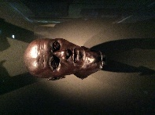  Nesyamun  An Ancient Egyptian Priest who lived c.1100 BC.  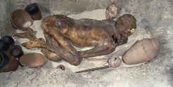  Ginger  A naturally mummified body dating c.3400 BC.
ancient | Something from a very long time ago.
artefacts | Objects made by human beings, typically of cultural interest.
civilisation | A human society with well-developed rules, often where technology and the rts are considered important.
embalming | The art and science of preserving human remains. |  | Maps
hierarchy | A system in which members of a society are ranked according to relative status or authority. |  | 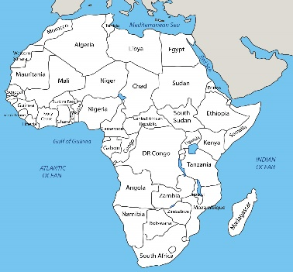  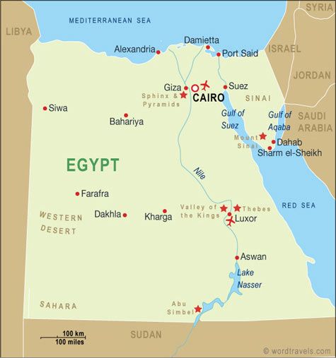
hieroglyphics | A system of writing that consists of pictures and symbols (hieroglyphs) instead of letters.
hieroglyphics |  | Hierarchy of Society
irrigation | A system of canals or channels dug by the Egyptians to supply water to grow crops over a larger area than the water would naturally reach. | 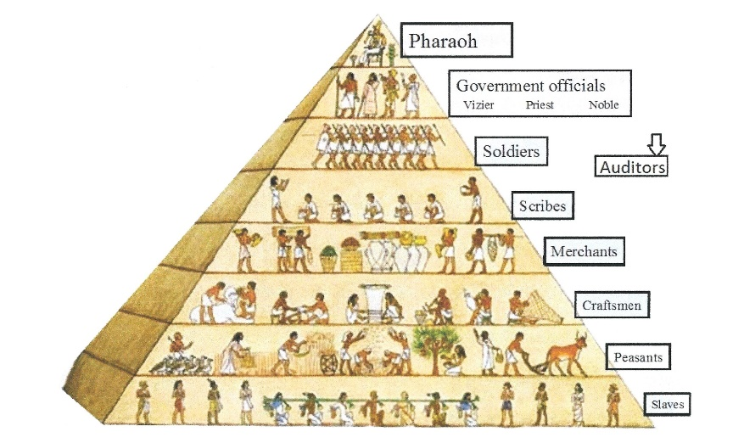
(The) Nile | A river that runs through Egypt. It was essential to life in ancient Egypt.
papyrus | A material similar to thick paper that was used in ancient times as a writing surface.
pharaoh | A ruler of ancient Egypt.
prehistory | The period of time before written records.
society | A group of individuals involved in social interaction.
tomb | A sealed room where a person was placed after death.
Timeline of Ancient Egypt
4000BC
Upper and lower Egypt
2700 – 2200BC
Old Kingdom
Middle Kingdom
New Kingdom
2100 - 1800 BC
1570 - 1080 BC

