Science |  | Seasonal Changes | Year 1
Key Vocabulary |  |   Key Knowledge and facts
word | definition | 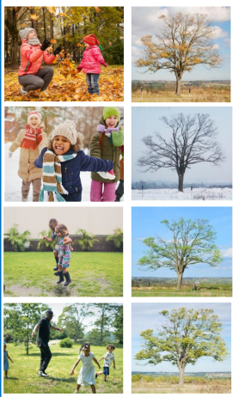  Autumn: The weather starts to get cooler.  The days get shorter and the nights get longer.  Leaves on some trees turn brown and fall off the trees.  Winter: The coldest season of the year.  Winter has the shortest day and the longest night.  The temperature is colder and there may be frost or snow.  Many animals hibernate in winter.  Spring: The weather starts to get warmer.  The days become longer and the nights get shorter.  New buds and plants begin to grow and new animals are born such as lambs and chicks.  Summer: The warmest season of the year.  The weather maybe hot and sunny.  Summer has the longest day and the shortest night.  In summer, the trees have green leaves on and new flowers and plants grow in fields and nature.
Autumn | A season between September and November
Hibernate | To sleep through the winter
Season | 1 of four parts of the year; spring, summer, autumn, winter
Spring | A season between March and May
Summer | A season between June and August
Temperature | How warm or cool something is
Thermometer | An instrument used to measure the air temperature.
Weather | The conditions and temperature outside
Winter | A season between December and February
