History |  | How has transport changed? |  |   Year 1
Key Vocabulary |  | Key Knowledge/events and facts |  | Key People
word | definition | - A horse and cart were used by people to travel and transport goods to other places  - George Stephenson invented the Rocket – a locomotive powered by steam. The steam engine changed the way people moved goods and travelled. Many city people were able to travel to the seaside for the first time.  - The Wright brothers were the first people to successfully fly in a plane. It could only carry the pilot and was made from wood.  - Modern planes are bigger and faster. They are made from metal and have big powerful jet engines. They can carry over 100 passengers.  - 1908, Henry Ford made a car called the Model T. It was the first car to be made in a factory and lots of these cars were made.  - The first rocket to reach space was the German rocket on a vertical test flight in June 1944.  - In 1969, Neil Armstrong was the first man to walk on the moon. | 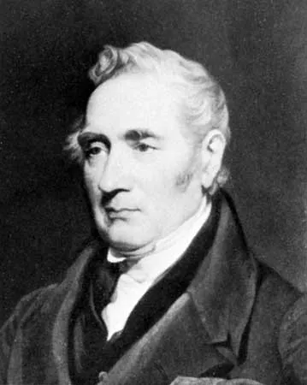  George Stephenson was an engineer and inventor. In 1829, he invented a steam engine called the Rocket  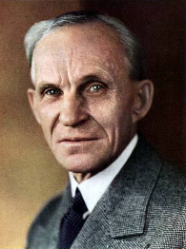  In 1908, Henry Ford was famous for making a car that many people could afford to buy. It was called the Model T.  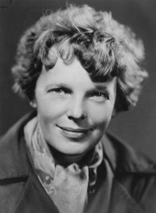  In 1928, Amelia Earhart became the first woman to fly across the Atlantic Ocean.
electric cars | Electric cars use electric to make the motor move.
inventor | someone who makes something that has never been made before.
petrol engine | A petrol engine burns petrol to make it move.
route | the way from one place to another
steam engine | A steam engine uses steam from water to make it move.
transport | carrying people or goods from one place to another
travel | moving from one place to another
vehicle | a thing used for transporting people or goods | Timeline
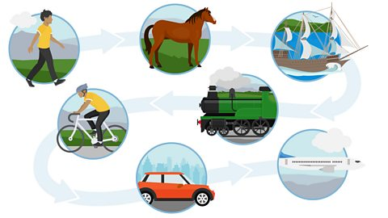 |  | 