Geography |  | Hot and Cold | Year 1
Key Vocabulary |  | Key Knowledge and facts |   Key Maps
word | definition | - The Arctic is a frozen ocean.  - The Antarctic is frozen land.  - Polar bears live in the North Pole (Arctic)  - Penguins live in the South Pole (Antarctic)  - The Arctic is home to lots of wonderful wildlife, including polar bears, arctic foxes, walruses, seals, whales and narwhals!  - The indigenous people of the Arctic are called the ‘Inuits‘.  - No one actually lives on Antarctica. It’s only scientists and visitors who go there!  - Antarctica is an icy desert. It is the windiest and coldest place on earth.  - The climate in Uganda, Africa is hot and dry.  - Uganda is on the equator.  - The Big Five are lions, rhinos, elephants, leopards and buffalo. | 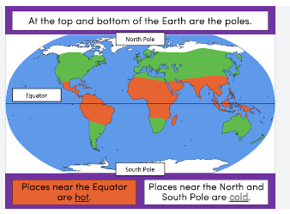  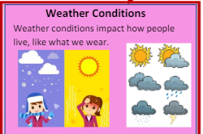  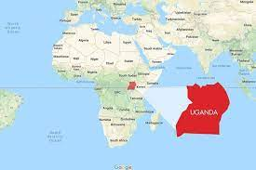  Uganda
Antarctica | Antarctica is the southernmost continent and site of the South Pole.
Arctic | The Arctic is a polar region located at the northernmost part of Earth.
Climate | The weather in a place over time
Desert | A region with very little rainfall
Continent | A continent is a large solid area of land.
Equator | An imaginary line around the centre of the earth.
North Pole | The Northern-most point of the Earth’s surface.
South Pole | The southern-most point of the Earth’s surface. | Animals
South Pole | The southern-most point of the Earth’s surface. | Polar animals | African animals
Weather | The conditions of the atmosphere e.g. rainy, sunny | 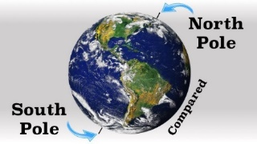  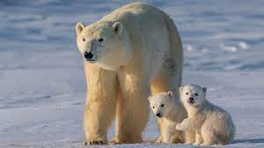  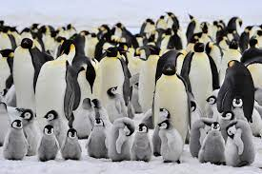  Polar bears are found on the North Pole and Penguins are found on the South pole. | 