Science |  | Sound | Year 4
Key Vocabulary |  |   Key Knowledge
word | definition | 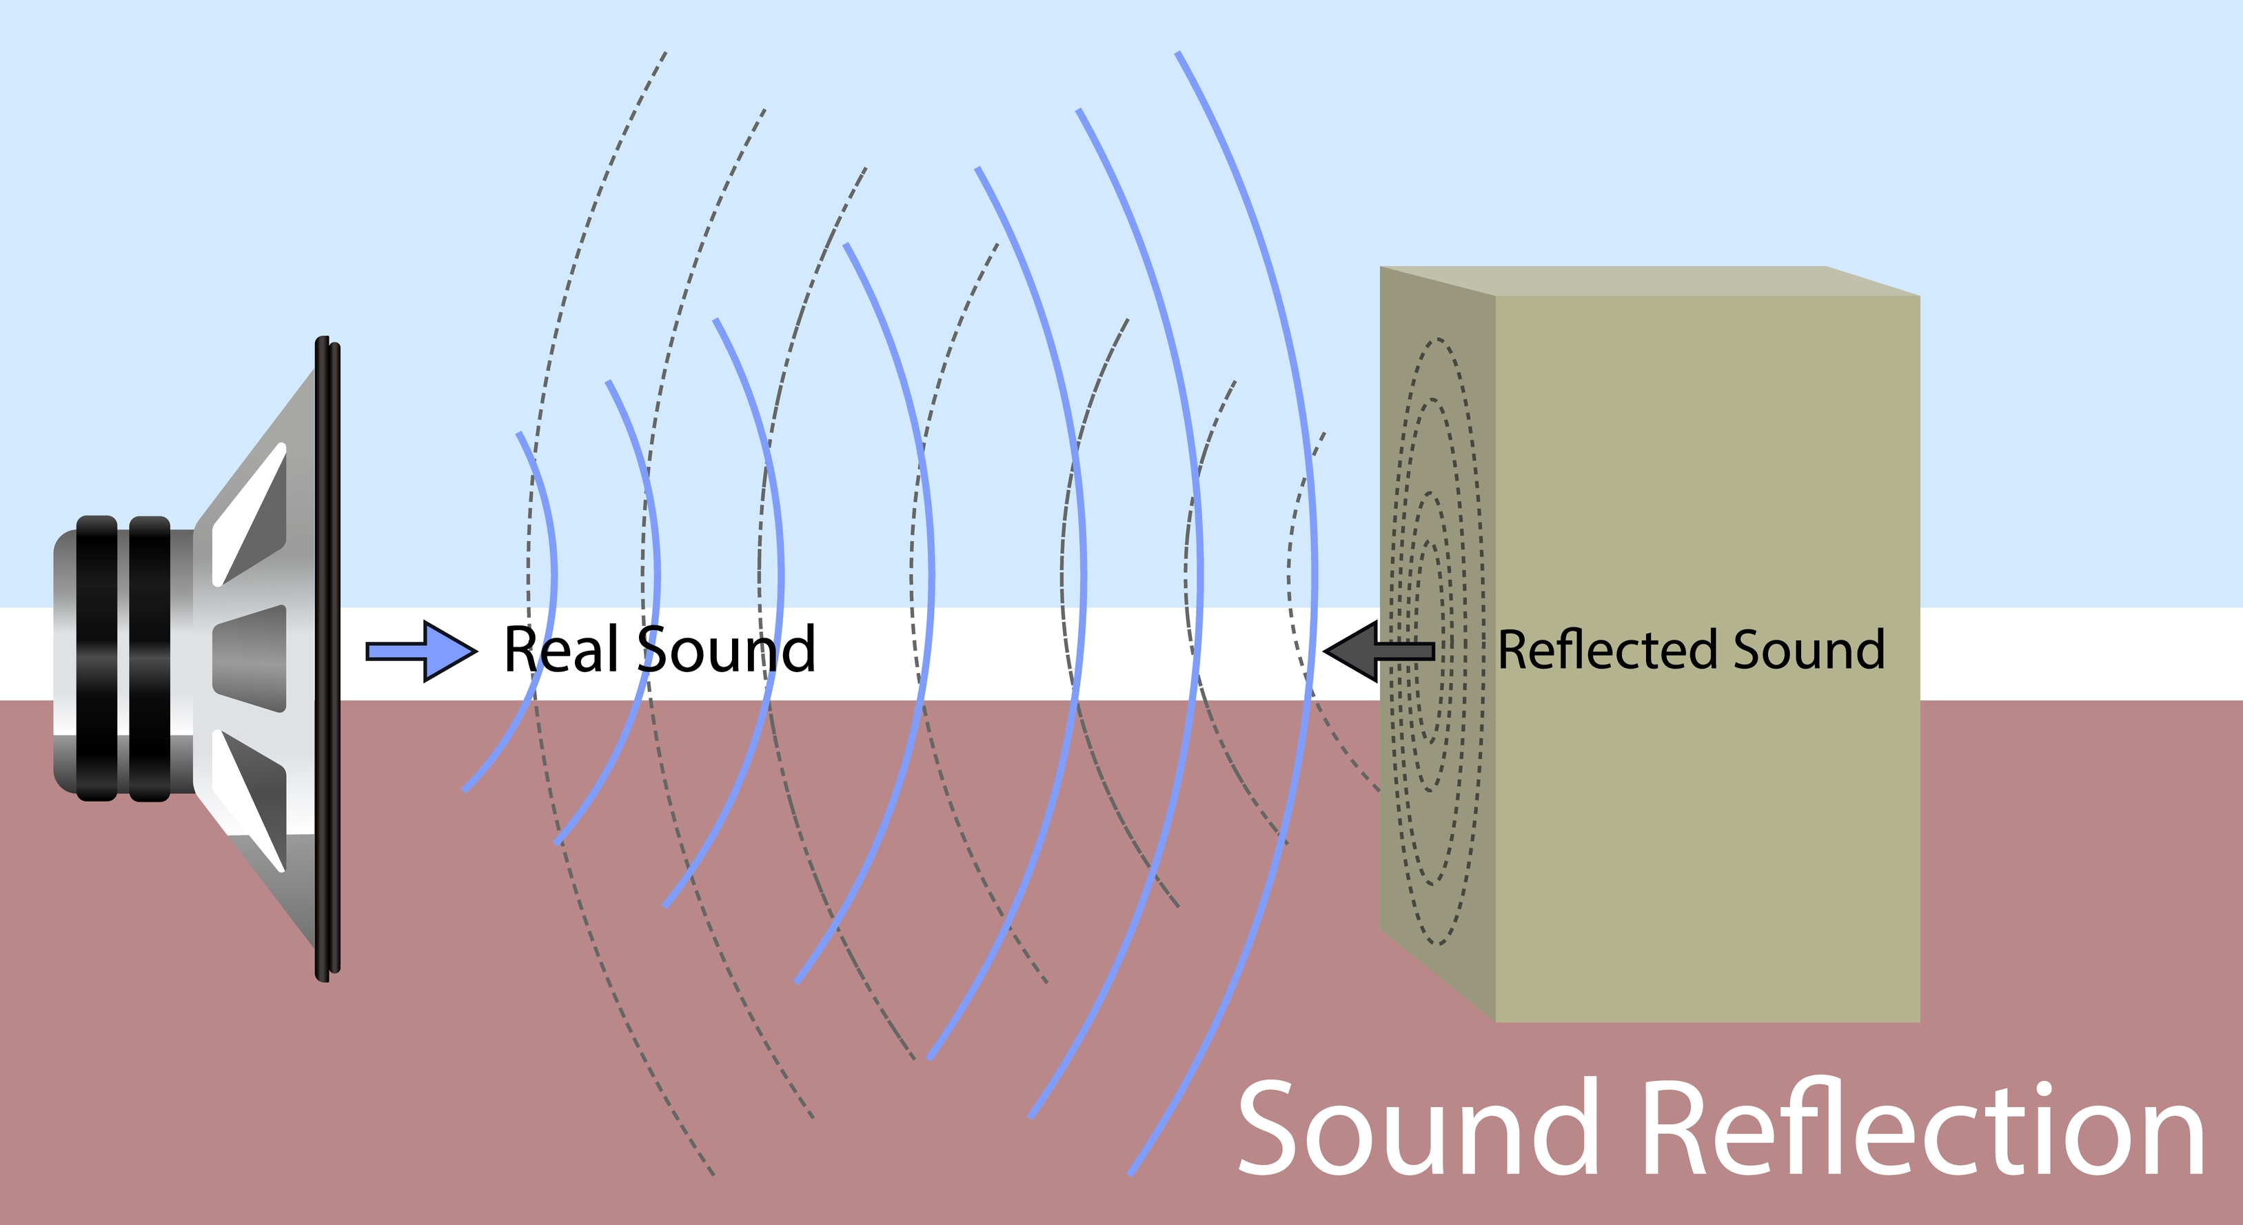  - Sound is a type of energy. Sounds are created by vibrations. The louder the sound, the bigger the vibration.  The sound waves travel to the ear and make the eardrums vibrate. Messages are sent to the brain which recognises the vibrations as sounds.  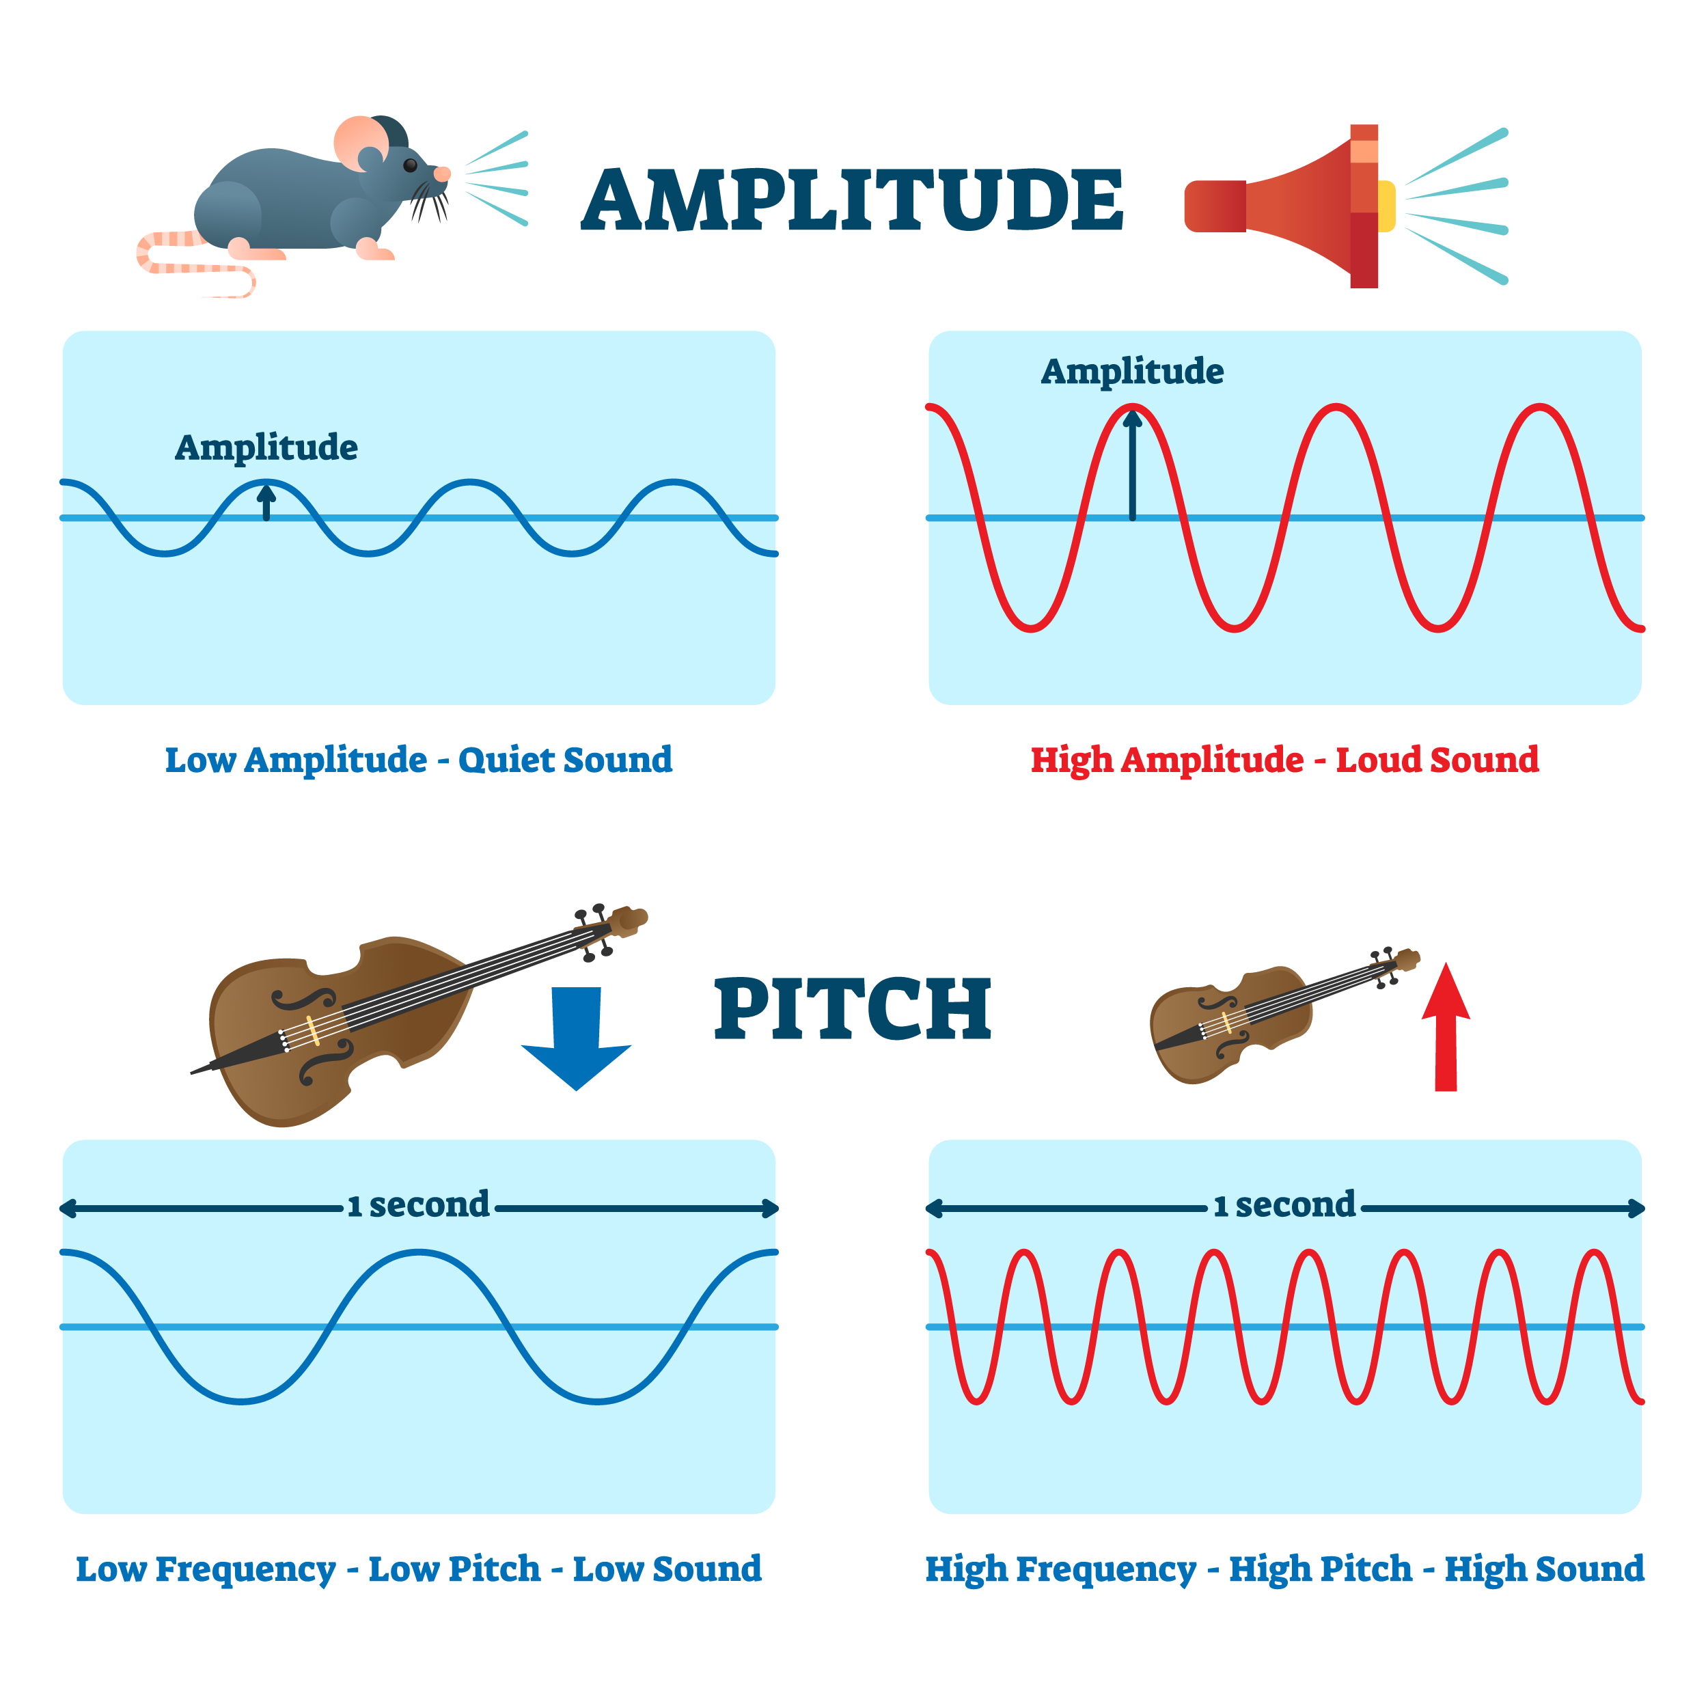  - Pitch is a measure of how high or low a sound is. A whistle being blown creates a high-pitched sound. A rumble of thunder is an example of a low-pitched sound.  - You can change the pitch of a sound in different ways depending on the type of instrument you are playing. For example, if you are playing a xylophone, striking the smaller bars with the beater causes faster vibrations and so a higher pitched note. Striking the larger bars causes slower vibrations and produces a lower note.  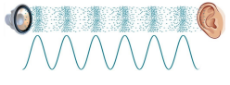  - Inside your ear, the vibrations hit the eardrum and are then passed to the middle and then the inner ear. They are then changed into electrical signals and sent to your brain. Your brain tells you that you are hearing a sound.  - Sound can travel through solids, liquids and gases. Sound travels as a wave, vibrating the particles in the medium it is travelling in. Sound cannot travel through a vacuum.  - The size of the vibration is called the amplitude. Louder sounds have a larger amplitude, and quieter sounds have a smaller amplitude
matter | Anything that has mass and volume (takes up space).
Amplitude | a measure of the strength of a sound wave.
Decibels | The units used to measure volume.
Energy | The power to make something work, move or grow.
Particles | Tiny pieces that make up something larger.
Pitch | How high or low a sound is.
Reflects | Bounces back from a surface.
Sound source | The start of the sound.
Sound wave | A vibration that travels through a solid, liquid or gas.
Vibration | A collection of particles moving very quickly.
Volume | How loud or quiet a sound is.
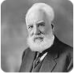
Key Scientist –
Alexander Graham Bell is a Scottish born scientist (1847) who invented the telephone in 1876 at the age of 29. He formed the Bell Telephone Company in 1887.

