Science |  | Everyday Materials |   Year 1
Key Vocabulary |  | Key Knowledge and facts
word | definition | - Objects are made from different materials (metal, plastic, fabric).  - Metal is used for spoons, forks and knives because they are strong.  - Plastic is used for lots of toys and objects because it can be flexible AND rigid.  - Fabric is used for teddies because it is soft and cuddly.  - Glass is used for windows because it is strong and transparent.  - Wood is used for tables and benches because it is strong. | We use lots of different materials every day. Some materials are used to make many things.
  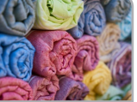  Fabric |   Metal
    Plastic | 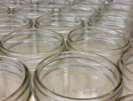  Glass
    Paper | 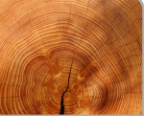  Wood
Absorbent | A material that is absorbent is one that soaks up liquid or moisture.
Bendy | If something is bendy, it can bend easily without breaking.
Dull | Doesn’t reflect light. Doesn’t look bright or shiny.
Flexible | Materials that can bend easily
Material | A material is what something is made of, such as wood or plastic.
Properties | The properties of a material tell us what it is like and how it behaves, such as whether it is soft, rough or transparent.
Rigid | Unable to bend or be forced out of shape
Shiny | An object that reflects light because it is very clean.
Soft | Not firm to touch. Not rigid.
Waterproof | Water cannot pass through an object or material that is waterproof.
