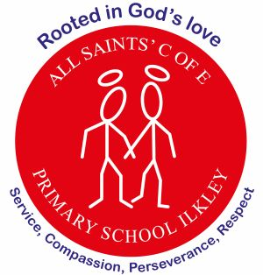
At All Saints’ Church of England Primary School, we are rooted in God’s love, serving our community with compassion, perseverance, and respect at the heart of everything we do.
Curriculum Letter
Year: Reception
Autumn 2
November 2025

Children’s Interests  We will continue following the children’s interests and ensure they are engaged and excited about their learning.  Encourage independent learning. |  | PE  We will continue to follow the spiral PE sessions.  PE will be on a Friday morning. If the weather is wet, please send your child in trainers instead of pumps.
Phonics  - We are continuing with our phonemes and including some digraphs.  - Your child will be sent home a reading book. This is the guided reading book which they will read in a session three times throughout the week. It will be sent home on Fridays. | Maths  - Comparing numbers – bigger and smaller  - Composition – wholes and parts  - Explore number facts to 5  - Counting, ordinality and cardinality |  | Religious Education  - Celebrating Christmas and practising our Christmas Nativity to perform to parents.  - Practising Christmas songs and speaking in front of an audience!  - We will be looking at Divali and the story of Rama and Sita.
Stay and Play Sessions  - All parents have been given the opportunity to come and play with their child. We really hope this is fun and exciting for you! |   Transport, Hibernation  And Christmas |  | PSHE  - I’m special  - Same and different - families and homes  - What it means to be a caring friend
Knowledge & Understanding of the World.  - Hibernation - how the weather is changing  - Hedgehogs and animals that hibernate  - Diwali  - Autumn changes | Outdoors  - Changing of the seasons and leaf collecting  - Number games  - Continue with planting of bulbs |  | Expressive Arts & Design  - Using the creative area to make poppy pictures.  - Clay hedghogs  - Playdough – making animals  - Space marbling inks  - Making vehicles
How parents/carers could help  - Stay and Play sessions – yippee!  - Sign up for our Christmas production!  - Read with your child please  - Remember waterproof coats |  |  | Music  Singing – learning songs for our Christmas nativity

