Science |  |  | Animals including Humans: Teeth and Digestion. |  |   Year 4
Key Vocabulary |  |  | Key Knowledge
word | definition |  | 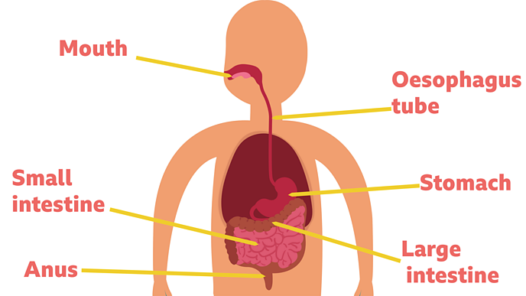  - The digestive system begins with the mouth and teeth where food is ingested and chewed.  - Saliva is mixed with the food which helps to break it up.  - When the food is small enough to be swallowed, it is pushed down the oesophagus by muscles to the stomach.  - In the stomach, food is mixed further.  - The mixed food is then sent to the small intestine which absorbs nutrients from the food.  - Any leftover broken down food then moves on to the large intestine.  - The food minus the nutrients arrives in the rectum where muscles turn it into faeces (poo). It is stored here until it is pushed out by the anus.
matter | Anything that has mass and volume (takes up space).
Canines | Used for tearing food.
digestive system | series of organs that break down food
enamel | very hard layer covering the tooth
fluoride | ingredient in toothpaste that helps prevent cavities forming
incisors | front teeth for cutting food
molars | wide, flat teeth for grinding food
oesophagus | tubes running from mouth to stomach
saliva | a fluid in the mouth which helps break down food
Small intestine | Where nutrients are absorbed from the food.
Types of Teeth |  | Different teeth have different functions |  | Food webs Vs Food Chains
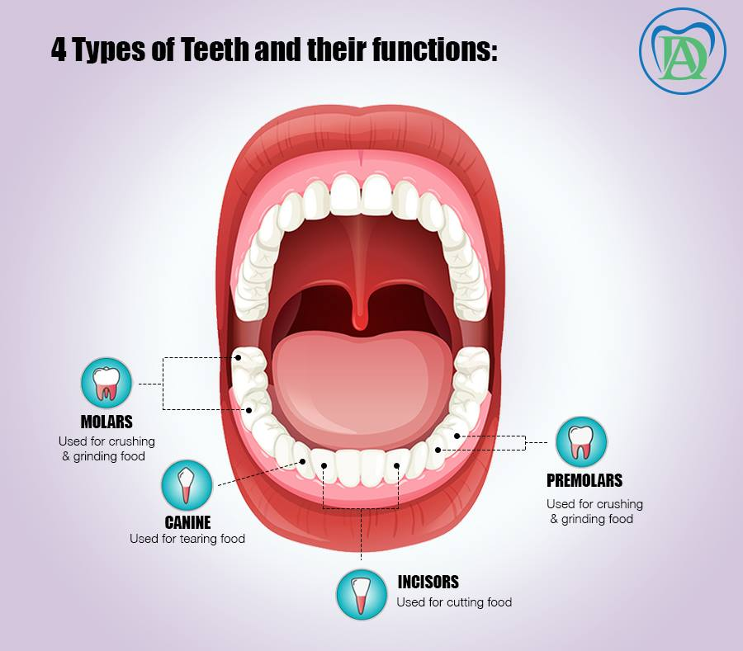 |  | Teeth of animals are designed for the foods they eat  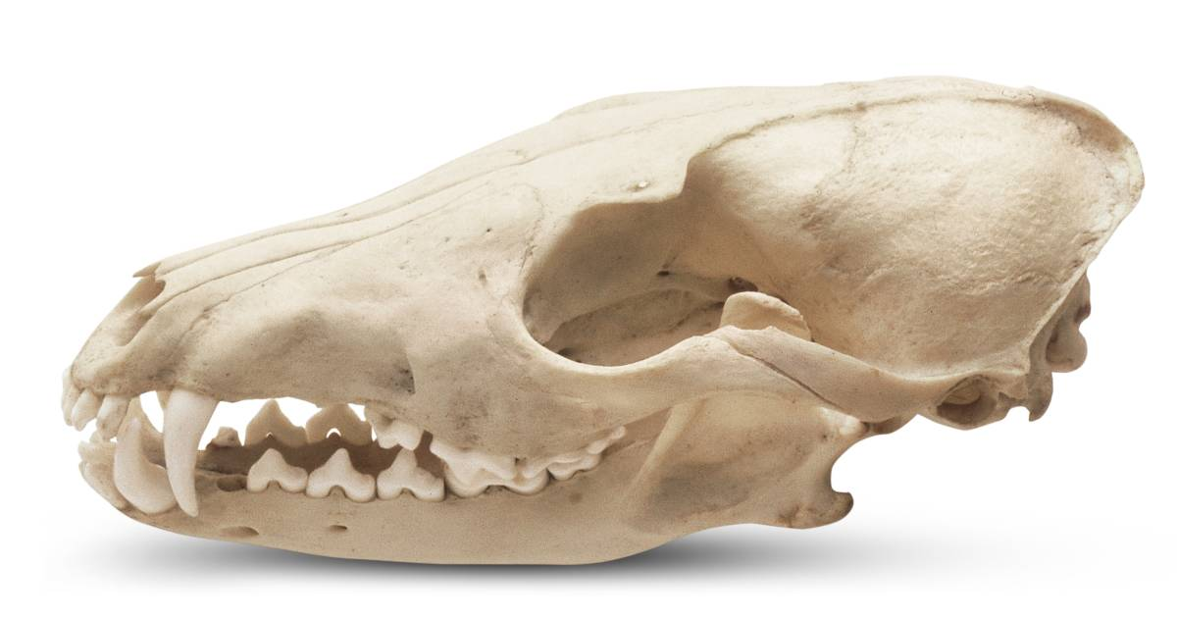  Herbivores (e.g., horses) have little use for canines and mainly use incisors and molars  Carnivores (e.g., Lion) mainly use canines and incisors, they don’t have molars (have premolars – small molars)  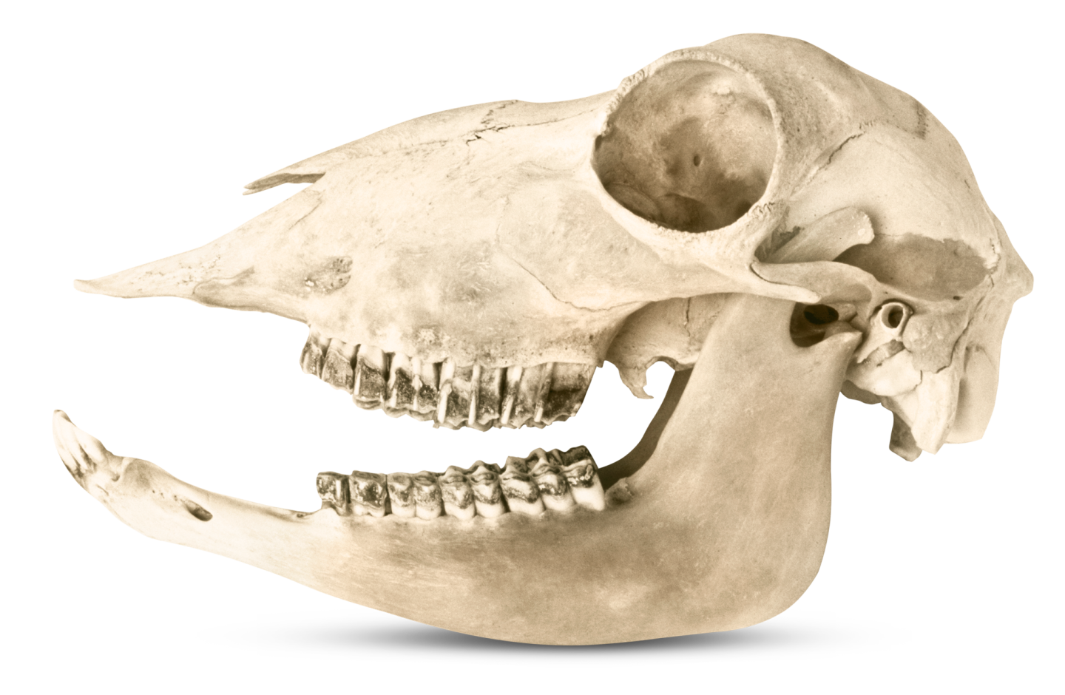  Omnivores (e.g., humans) use all three  Tooth enamel is the hardest substance in the human body. Humans have two sets of teeth; milk teeth and adult teeth |  | 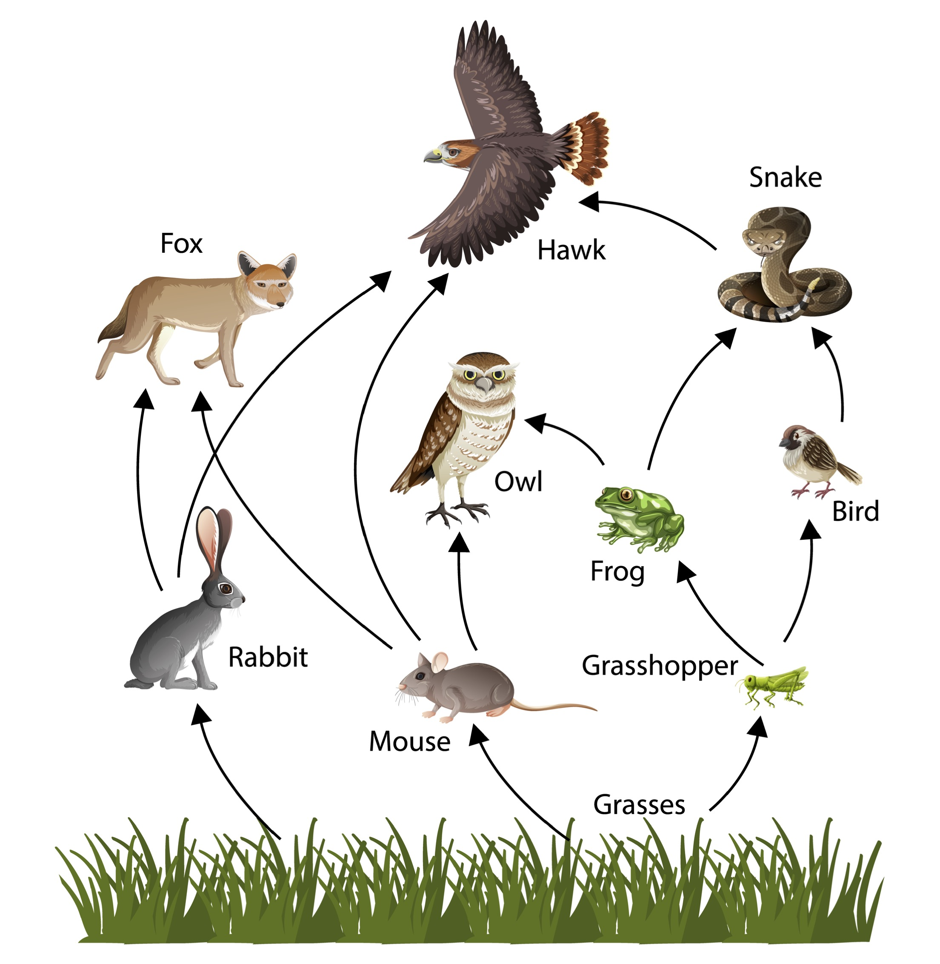  Food Web  Food Chain  