History |  | The Romans |   Year 4
Key Vocabulary |  | Key Knowledge
word | definition | The Celts can be referred to as the pre-Roman people of Britain. Celts lived in Britain from roughly 600BC to 43AD but were known as Britons.  The ancient Romans became one of the most influential civilisations in history, conquering areas in Europe, Africa and Asia.  Julius Caesar first invaded Britain in 55 and 56 BC. There were battles between the Roman army and the Celts, but the Romans didn’t have a large enough army and they retreated. Emperor Claudius invaded in 43 AD the Romans finally conquered Britain. |  | The Romans built new towns. They had a grid structure and featured a forum, basilica, and public baths.  The Romans developed many things that had been used before and made them better, such as sewers, aqueducts, and roads  The Romans built about 55,000 miles of roads across the empire. They built very straight roads, many of which are still used today  The Romans left Britain because the empire was being attacked in other countries, so soldiers were called to fight elsewhere
Aqueduct | A manmade channel used for delivering water to Roman towns
Barbarian | A term used used by the Romans to refer to people who lived outside the Roman Empire
Basilica | A large building used for meetings and discussing legal matters in ancient Rome.
Century | A division of the Roman army made up of 80 soldiers and led by a centurion
Consul | The highest position in the Roman government
Emperor | The leader of an empire
Gladiator | A person who fought for the entertainment of Roman audiences | 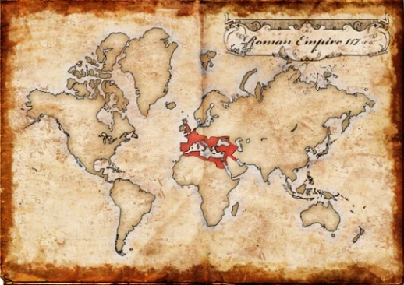  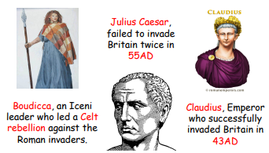  Influential People A map showing the reach of the Roman Empire  Timeline  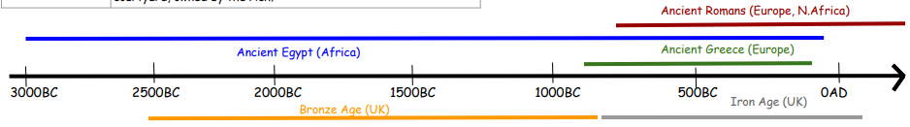
Latin | The common language of the Roman Empire
Legion | The main unit of the Roman army
Mosaic. | Picture or patterns made of small tiles. They were used to decorate walls or floors in Roman buildings
Rebellion | When people refuse to follow someone who is in charge, in a rebellion people may try and overthrow the ruler
Senate | A group of prestigious men who advised the consuls.
Villa | A large country house around a rectangular courtyard, owned by the rich

