Science- Living things and their habitats - Conservation |  | Summer 2 - 2024 |   Year 4
Key Vocabulary |  | Key Knowledge
word | definition | How environments change:  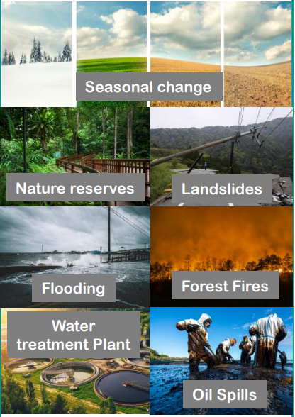 | Why environments change:  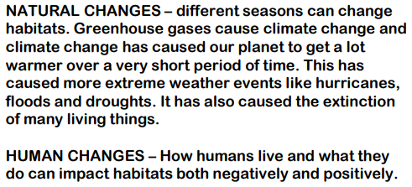  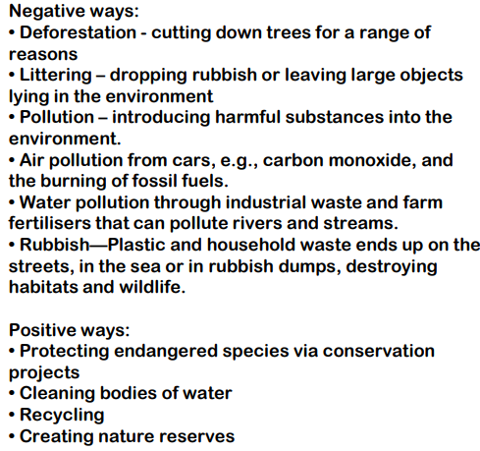
matter | Anything that has mass and volume (takes up space).
Biodiversity | The variety of living things
Conservation areas | Areas on land or sea that protect the wildlife from harm
Marine sanctuaries | Ocean areas that protect the wildlife from harm
migrate | To move from one area to another
monsoon | Rainy season
Freshwater | Water that does not contain salt
deforestation | The cutting down of forests, including rainforests
emissions | The production or discharge of something, especially gas or radiation
pollution | Harmful or poisonous substances
pesticide | A chemical substance used to kill insects that harm or eat plants and crops
contaminate | To make something impure by adding poisonous or polluting substances
drought | A long period of time with a shortage of water

