Science |  | Plants | 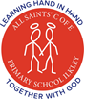  Year 1/2
Key Vocabulary |  | Key Knowledge and facts
word | definition | 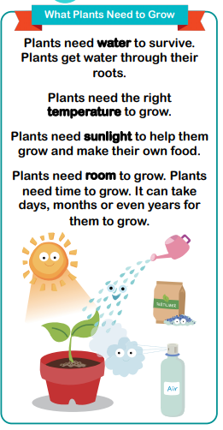 | 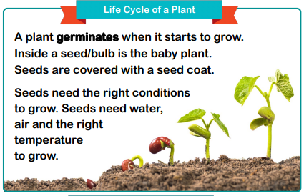  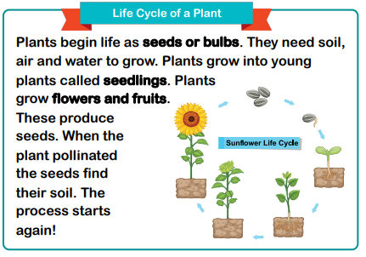
bulb | a plant bud that begins to grow underground
germination | the process by which a plant grows from a seed
investigate | to observe closely through testing
life cycle | a series of stages a living thing goes through during its life
plant | a living thing that uses sunlight to make their own food
pollination | the process that allows plants to reproduce
reproduction | the creation of new plants by one or more parent plants
seed | a part of a plant from which a new plant can grow
seedling | a young plant grown from seed
temperature | temperature is how warm or cold something or somewhere is
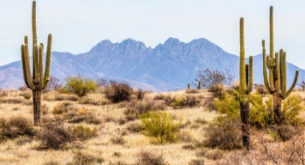    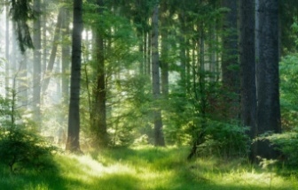  Plants in  different  habitats |  | 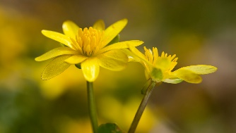  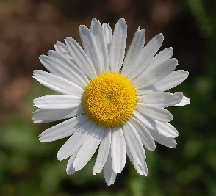  Can you find any of these plants around school?  