Geography |  | Rainforests |   Year 4
Vocabulary |  | Layers | Deforestation
climate | The average weather conditions over a long period of time. | 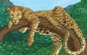  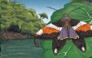  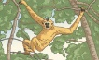  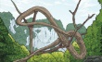  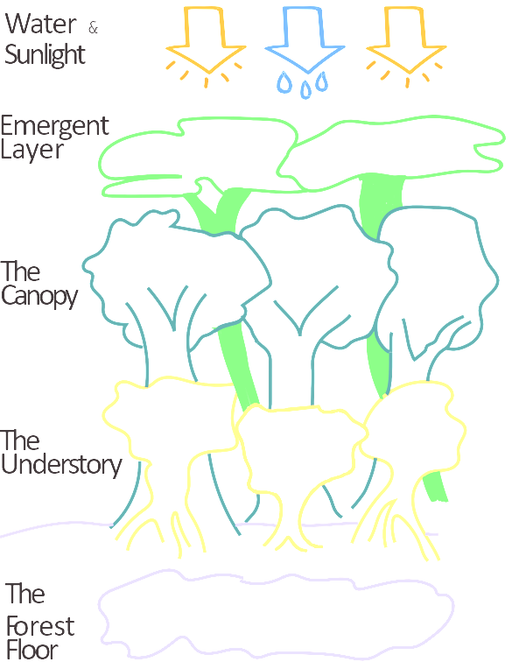  Very few plants. Almost no sunlight. Leaves and debris decompose quickly. Gorillas, anteaters, leopards and tigers.  Trees form a roof over the plants below. Lots of sunshine but also plenty of rain. Lots of food for animals. Snakes, toucans and tree frogs.  Trees grow to less than 4m tall. Very little sunlight. Warm and humid. Lots of insects.  Trees can be up to 60m tall. Lots of sunshine. Cold and windy. Birds, bats, monkeys and butterflies. | Trees are cut down:  - To create fields for farming cattle and growing crops,  - to produce timber and wood pulp to make furniture and paper,  - to create space for housing.  Positive Impacts Negative Impacts  - Jobs are created in logging and transporting timber and manufacturing products. - Selling land raises money for local people. - People’s homes are destroyed. - Animals and plants may become extinct through habitat loss. - Plants that may have been useful could be lost.
deforestation | The cutting down and clearing of forests.
equator | An imaginary circle running round the centre of the earth.
humid | Feeling very damp due to water vapour in the air.
Native tribes | The original settlers of an area.
species | A group of similar animals or plants.
tropical | Somewhere that is warm all year round, but which has rainy seasons.
Where in the World? |  | Key Facts
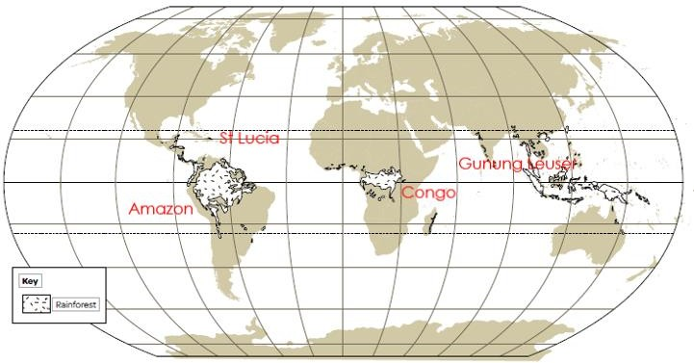  Tropic of Capricorn  Tropic of Cancer  Equator |  | Tropical rainforests are found north and south of the Equator between the Tropics of Cancer and Capricorn.  A rainforest has many layers of vegetation (plants) growing within it. All of these plants grow to different heights and create layers within the rainforest.  Rainforests are home to over half the species of plants and animals in the world and are a fantastic source of foods and medicines. They cover less than 2 per cent of the planet but contain an estimated 50 per cent of all life on earth’s land masses.  Habitat loss is the main cause of extinction. Deforestation (at a rate of about 300,000km2 a year) has been caused by commercial logging, mineral extraction, commercial farming and subsistence farming.

