Geography |  | An Island Home |   Year 1/2
Key Vocabulary |  | Key Knowledge and facts | Key Maps
word | definition | - There are 7 continents - from largest to smallest they are: Asia, Africa, North America, South America, Antarctica, Europe, Australia (also known as Oceania).  - Sydney is a large city in Australia.  - The capital of Australia is Canberra.  - There are 4 countries that make up the UK – England, Scotland, Wales and Northern Ireland.  - The capital of England is London.  - The capital of Wales is Cardiff  - The capital of Northern Ireland is Belfast  - The capital of Scotland is Edinburgh.  - The Isle of Coll is off the coast of Scotland.  - The Great Barrier Reef is a coral reef and can be seen from space!  - Australia has warmer weather because it is nearer the equator. | 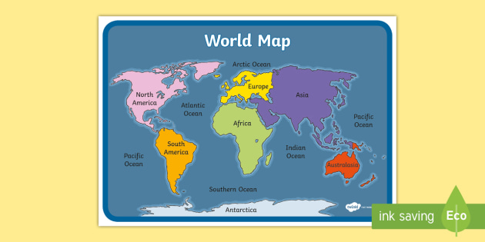  Continents of the World  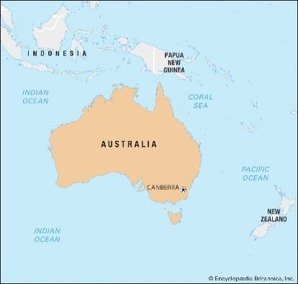  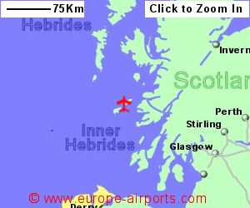  Isle of Coll  Australia
Continent | A continent is a large solid area of land.
City | A large settlement of people found within a country.
Equator | An imaginary line around the centre of the earth at O° latitude.
Human Features | Features made by humans (city, village, farm, shop).
Island | A piece of land that is completely surrounded by water.
Landmark | A building or feature that is easily recognised.
Physical features | Natural features on the Earth's surface ( beach, forest, ocean)
Village | A small group of houses in a country area. | Famous Landmarks
 |  | Physical Features | Human Features
Weather | Conditions created by day to day changes in the earth’s atmosphere. | 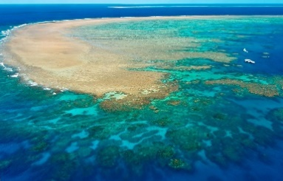  Great Barrier Reef  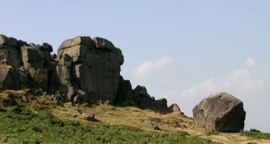  Cow and Calf Rocks | 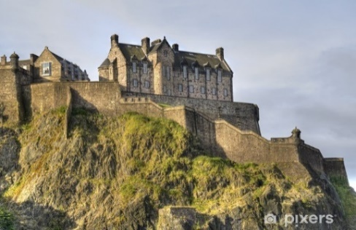  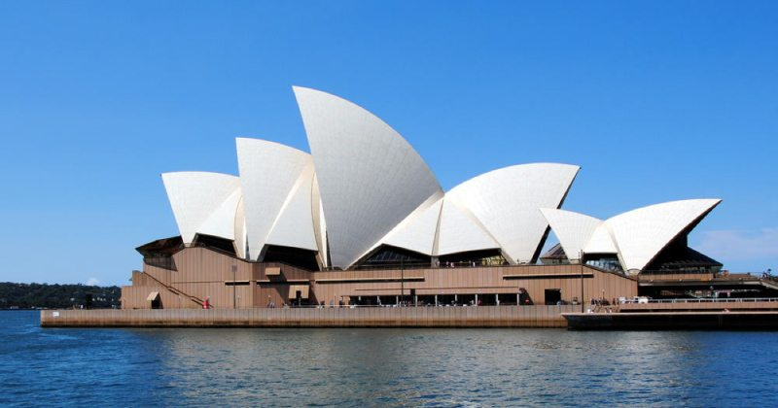  Edinburgh Castle  Sydney Opera House
An island
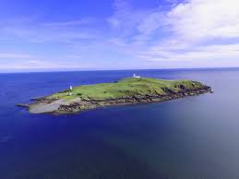
St Paul’s Cathedral
The Monument

