History |  |  | History of the seaside |  |  |   Year 1-2
Key Vocabulary |  |  | Key Knowledge/events and facts |  |  | Key People
word | definition |  | 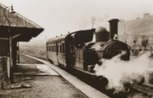  - People have been going on seaside holidays for over a hundred years.  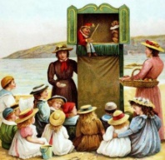  - During the 19th century, the development of railways allowed more people to visit different seaside resorts. As rail fares became cheaper, more people would travel further and more often.  - Punch and Judy is a funny puppet show, common at the seaside in the Victorian times.  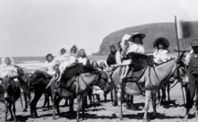  - Bucket and spades would be very heavy to carry. They were made from metal, tin and wood. Donkey rides, entertainment and carousels on the pier are still popular today.  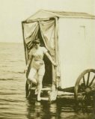  - Bathing machines were invented for the upper class so they could get changed into their bathing costumes in privacy.  - Victorians believed that if you were unwell, drinking sea water and breathing in fresh, sea air would make you feel better.  - Piers were created for the upper class so they could be near the sea without getting wet. |  | Grace Darling  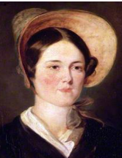  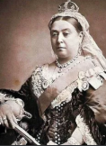  Grace Darling was a Lighthouse Keeper’s daughter who helped to save 9 people after a ship crashed into the rocks and sank off the Northumberland coast in 1838. She was 22 years old when the rescue took place. Grace Darling became a heroine after her heroic actions. Queen Victoria wrote a letter and gave a reward to Grace Darling.  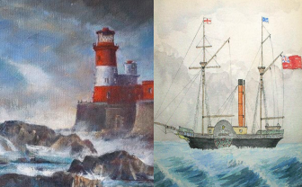
bathing machine | Bathing machines were used a long time ago so people could change in private before getting into the sea
coast | The part of the land that is near the sea.
hokey pokey | The name given to an ice cream a long time ago. It was usually eaten out of paper.
pier | A wooden structure on pillars that goes from land out over water.
promenade | A paved public walk along the seafront.
seaside | A place by the sea, especially a beach area or holiday resort.
souvenir | Something that is kept as a reminder of a place visited.
Timeline
Grace Darling 1838 |  | Scarborough 1894 |  | Scarborough 1960 |  |  | Scarborough 2025
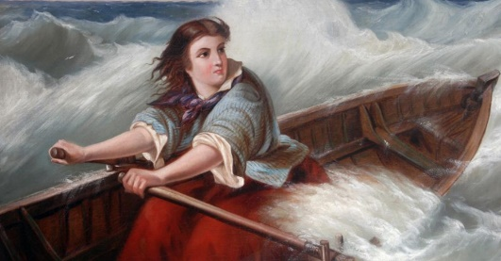 |  | 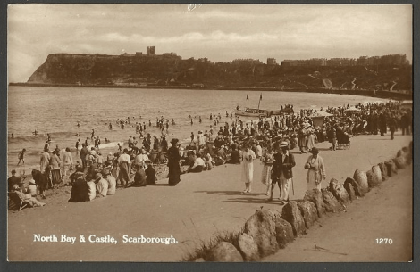 |  | 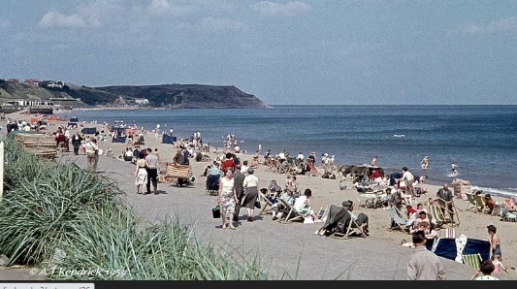 |  |  | 