SEND Information report 2021/22.
For the more in depth information report follow the link;
The kinds of Special Educational Needs provided for at All Saints CE Primary School , Ilkley. | Here at All Saints CE Primary we provide support for pupils across the 4 areas of need as laid out in the SEND Code of Practice 2014:  - Communication and Interaction  - Cognition and Learning  - Social, Emotional and Mental Health difficulties  - Sensory and/or Physical needs
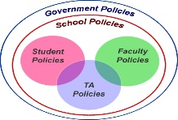  - Information about the school’s Policies for identification and assessment of pupils with SEND.  This Photo by Unknown Author is licensed under CC BY-SA  This Photo by Unknown Author is licensed under CC BY-SA | When pupils are identified as having SEND, their needs will be assessed, through a variety of methods:  - Transition information passed on from Nursery/previous schools;  - Foundation scores/KS1 results, or Baseline testing and Progress data;  - Observations and feedback from teaching staff;  - Interventions not showing the impact expected;  - Referrals/concerns from parents;  - Pupil referrals.
2a. Evaluating the effectiveness of the provision made for pupils with SEND.  This Photo by Unknown Author is licensed under CC BY-NC-SA | Impact tracking is carried out on a termly basis with teachers and Senior Leadership team and adaptations to provision made in light of these findings.  School uses the Graduated appraoch (assess, plan, do review format). Progress and evaluation is discussed with teachers then reported on a termly basis to the Governor with responsibility for SEND.  SENDCo presents a termly written report and a Annual report in person to the Governing Body.  SEND Information Report posted on the Web site.

2b Arrangements for assessing & reviewing pupils’ progress towards outcomes, including opportunities available to work with parents & pupils as part of this assessment and review  This Photo by Unknown Author is licensed under CC BY-NC-SA | These arrangements include:  - Data tracking for pupil progress using schools tracking system  - Termly meetings with staff and SENDCo  - My Support plan and ECHP reviews  - Observations and follow up with teaching staff  - Discussion with parents about pupil’s next steps in their development and learning.
3 The school’s approach to teaching pupils with SEND, with adaptations to curriculum and environment. | Provision and adaptations for pupils with SEND may include:  - Quality first teaching, with appropriate differentiation of resources and teaching styles  - Extra adult support in classrooms where/when appropriate  - Reduced class sizes and groupings that target specific levels of progress, where appropriate  - Personalised provision through time limited programmes  - Personalised provision through adapted resources and interventions  - Appropriate choices of texts and topics to suit the learner  - Access arrangements for tests and or examinations.
4 The arrangements for consulting parents of children with special educational needs about, and involving such parents in, the education of their child. | Parents meetings;  - Termly additional to parents evening. These are with your pupil’s teacher and SENDCo if staff or parents request  - At EHCP annual reviews or interim reviews if needed  - Meeting with school’s Pupil support worker if needed  - Team around the family meetings if needed for all stakeholders to meet and discuss support needed for the whole family as well as the pupil in school  - Early help meeting with a Bradford council representative if needed

5 Support that is available for improving the social emotional and mental health of pupils with special educational needs  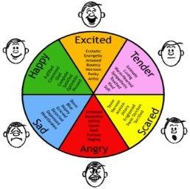 | Pupils are well supported by:  - A strong focus on safeguarding and close liaison with their class teacher/support/SENDCo.  - An anti-bullying policy that is supported by a specialist trained member of staff.  - Regular interventions on Cyberbullying and other areas relating to individual emotional and or mental health needs  - A social, emotional and mental health support that provides programmes such as small nurture groups, anger management, self-esteem building, resilience, perseverance, grief etc.  - Targeted support for individual pupils  - Jenby’s support programme  - School Council  - Pupil Voice both in person or through the questionnaire
This Photo by Unknown Author is licensed under CC BY-SA
6 Information about specialist help to support children with special educational needs | Information can be found;  - Local Authority SEND website  - Local Offer http://localoffer.bradford.gov.uk/  - Support Services within education authority  - Charities. (See Full document for full list of charities in our area)
7 Information about the expertise and training of staff in relation to children with SEND, including how specialist expertise will be secured. | Audit of staff expertise in SEND undertaken bi-annually via questionnaire;  - SENDCo has B.Ed Hons and SENDCo qualification  - Effective use of adult support for Literacy and Mathematics where needed  - Individual training re : Dyslexia , ADHD, ASCD, Positive handling, Specific learning difficulties where needed  - Some staff trained to diploma level qualifications for communication needs, ELKLAN.  Specialist expertise engaged from external services –  Social, Communication, Interaction, Language team (SCIL), EP support, Low incidence team, CAMHS Counselling, Jenby’s etc.
8 How adaptations are made to the curriculum and the learning environment of pupils with SEND | Parents and carers are consulted about trips, residentials and adaptations are made to ensure all children can access all aspects of school life, where appropriate to their needs.
9 How pupils are able to independently move round school.  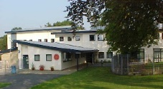 | School is a 2 floor site with;  - Lift to first floor  - Evac chair for evacuation in event of fire  - ‘Access to all’ toilet on the ground floor with changing/washing facilities with accessibility for visitors with a disability  - Disabled parking near to school entrance with same level entrance and exit to building  - Ramps where needed into school to ensure the site is accessible to all  - A medical room has been provided in order to enable a safe place for insulin testing/injections  - Wellbeing room has been developed to improve facilities for a quieter space for vulnerable pupils.
10 How pupils are supported through transferring between settings.  This Photo by Unknown Author is licensed under CC BY-NC | School works closely with settings during transition times;  - Specific meetings with settings and staff involved with pupils  - Visits to new settings, specific to pupils and their needs.  - Staff and parents meet.
11 How resources are matched to young person’s needs. | Funding is used in a variety of ways e.g. purchase of specialist resources and equipment; employment of staff to provide intervention programmes, staff training etc. Each pupil’s needs are considered individually and the resources they need will be provided, where possible.  The funding is managed by the Head Teacher and school business manager, ensuring the funding available is spent wisely to support the needs of children who require additional support.
12 How is the decision made about the type and how much support my child/young person will receive? | Quality First Inclusive Practice is clearly defined in our school and we expect all staff to decide upon the appropriate provision within the classroom and deliver this in the first instance on a daily basis.  The SENDCo and leadership team monitor the pupils who are undertaking interventions to check the desired outcome is being achieved and progress being made.  A child will be added to the school SEND register by the SENDCo only after consultation with other staff and parents, and after close monitoring of progress and needs. There will then be additional meetings across the year when required, to discuss and review the provision and make any further decisions together, in consultation with parents.
13 Involvement in pupil’s progress and contact with class teacher.  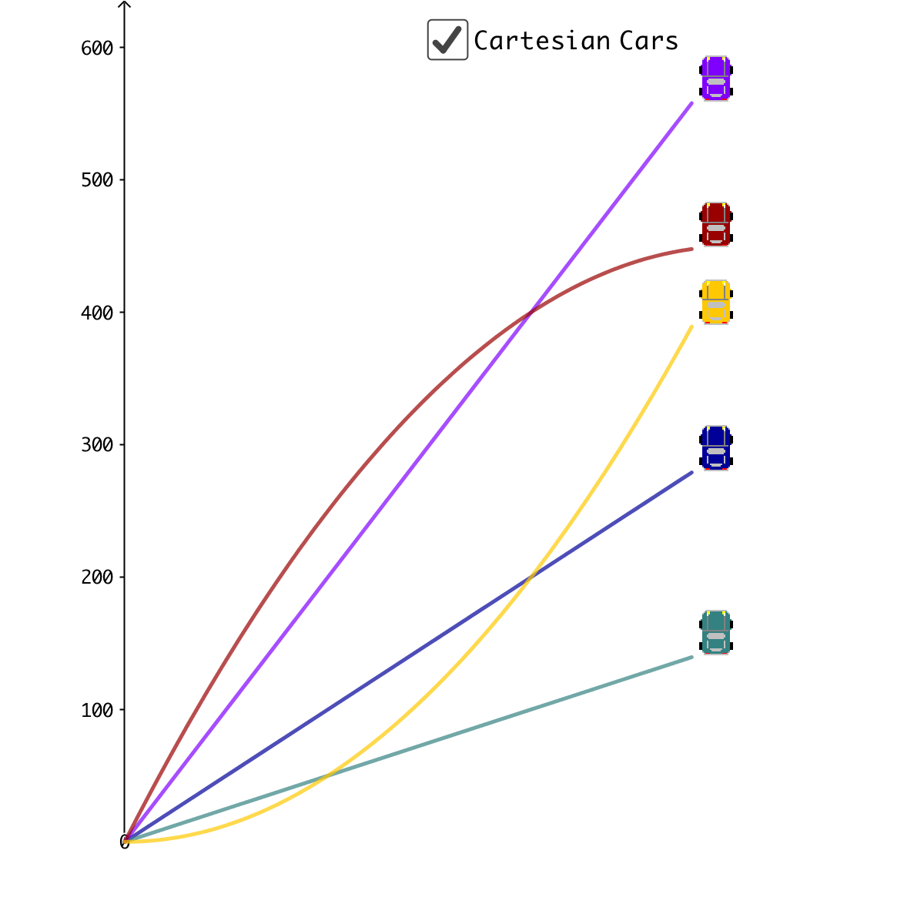 | Parents can contact staff via;  - Telephone  - Email office  - In person at start and end of the day  - Parents Evenings  - Family Support worker  Meetings are held seveal times a year with class teacher and SENDCo is requested, to discuss provision and attainment.
14 Information on where the local authority’s Local Offer is published and school contact details. | To contact ;  - SENDCo; Miss L King, contact school office on 01943 607852 or email.  - SEND Governor; Mrs C Falknor, contact same as above school office.  - Bradford Council Website. http://localoffer.bradford.gov.uk/
14 Information on independent support organisations . | Local support agencies;  - For full list of agencies see Full School Information report.

