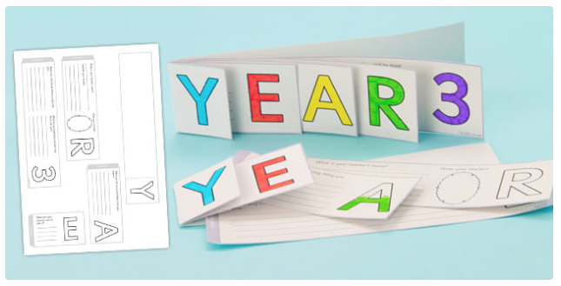

To make this ‘end of year’ book:

1. Cut out each piece.
2. Write in each section.
3. Colour and decorate.
4. Fold the ‘Y’ over so that it is showing at the front.
5. Write down any worries or questions you have about next year.
6. Glue the tab on each of the other pieces.
7. Stick the other tabs in the correct order
8. Enjoy flicking through your book.



**3**

Draw your teacher!

Stick here

Stick here

Stick here

Stick here

What are you looking forward to most about next year?

_________________________________________________________________________________________________________________________________________________________________________________________

Name any new friends that you made this year…

_________________________________________________________________________________________________________________________________________________________________________________________

What was the most interesting thing you learnt?

_________________________________________________________________________________________________________________________________________________________________________________________

**R**

What was your favourite part of year 3? ______________________________________________________________________________________________________________

**E**

What is your teacher’s name?

_____________________________________Describe your teacher…

________________________________________________________________________________________________________________________________________________________

**A**

**Y**