Year 2 weekly plan W/B 13th July 2020
 | English | Maths
Monday | Spellings – compound words  Compound words are formed when two words are put together to form a new word with a new meaning. Foot+ ball = football. Watch the following videos.  https://www.youtube.com/watch?v=EVIHVSJ4flI&feature=emb_rel_end  Compound Boogie  https://www.youtube.com/watch?v=jP88434Whjs  There is also a power point for you to see. When done complete the sheets. | Lesson 1 – Telling time to 5 minutes  Watch the white Rose Maths Video on ‘Telling time to 5 minutes’ (See link) and complete the accompanying activity sheet. You can download the accompanying sheets from our home learning page.  https://vimeo.com/436534877
Tuesday | Guided reading-Tasty travels  Read the following e-book and answer the questions on the accompanying sheet.  https://www.oxfordowl.co.uk/api/interactives/12961.html | Lesson 2 - Hours and days  Watch the white Rose Maths Video on ‘Hours and days’ (See link) and complete the accompanying activity sheet.  https://vimeo.com/436535258
Wednesday | World food research – (see theme work)  Research of own food  Over the next couple of days, you are going to carry out some research into either the food from a particular country e.g. (Italy/China/India/Greece) or research a chosen food from somewhere in the world e.g. Chocolate/bananas/coconuts. | Lesson 3 - Durations of time  Watch the white Rose Maths Video on ‘Find durations of times’ (See link) and complete the accompanying activity sheet.  https://vimeo.com/436535580
Thursday | Research presentation  Using the notes you have made, think about how you want to present your research. It could be an information sheet, a poster, a leaflet even a mini – book. Write up your notes and add pictures too. If you want, (parents can help) you can make a power point of your chosen world food. | Lesson 4 - Compare durations of time  Watch the white Rose Maths Video on ‘Compare durations of time’ (See link) and complete the accompanying activity sheet.  https://vimeo.com/436535718
Friday | Write an invitation (See Art Planning)  You are going to design a party invitation and a party menu – for your chosen world food. The invitation could be for a family party or for a teddy bear’s picnic. Look at the help sheet to see what needs to be on an invitation – Date, Place, Time. What is the theme? Who are they replying to? Be creative!  Spelling dictation (see download sheet) Read the passage a sentence at a time to your child for them to copy into their blue spelling book. The passage incorporates the weekly spellings and other high frequency words. | Complete the ‘Friday maths challenge’  (Summer term- week 12, lesson 5).  https://whiterosemaths.com/homelearning/year-2/

Theme |  | Art/DT
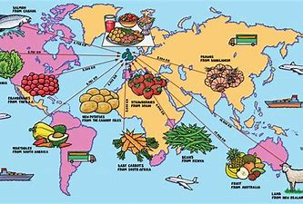  Have a think about some of your favourite foods. Spaghetti? Pizza? Burgers? Chat to your mummy and daddy. What were their favourite foods when they were little? What were grandma and grandad’s favourite foods when they were little? Did they have lots of different types of foods to choose from when they were little like you do today?  Nowadays we are lucky to have a huge variety of different foods to eat which come from different countries around the world. Where does your favourite food come from?  Have a go at matching the food with its country of origin (where it comes from) on the worksheet on the resources page. To do this you can do some of your own research or use the PowerPoint.  Extension. Can you find the countries on a world map? | English/Theme - Research of own food  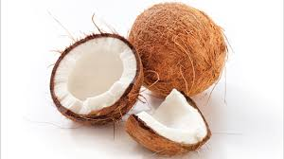  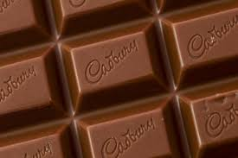  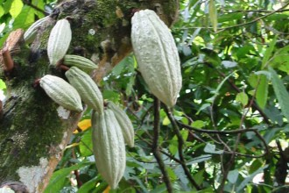  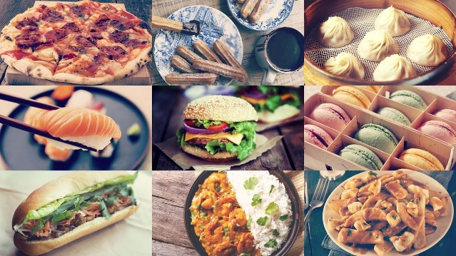  You are going to carry out some research into either the food from a particular country e.g. (Italy/China/India/Greece) or research a chosen food from somewhere in the world e.g. Chocolate/bananas/coconuts. Make notes about your food. What it is. Where it comes from. What food is eaten there. Use information books, recipe books or the internet. The following websites have information about world food.  https://www.kids-world-travel-guide.com/  https://www.kids-world-travel-guide.com/food-facts-for-kids.html  https://www.sciencekids.co.nz/sciencefacts/food.html  You could find out what countries eat for breakfast or lunch or what food is eaten for certain celebrations. The world is your oyster!  https://www.youtube.com/watch?v=ry1E1uzPSU0  https://www.llworldtour.com/most-popular-food-in-cities-around-the-world/ (quite wordy – parents may need to help your child to navigate the site) | Party Time  (See Friday’s English)  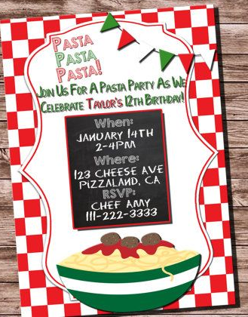  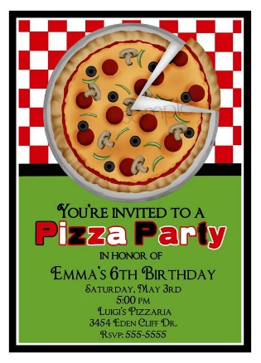  Party food is a big part of a party. Think about the world food you have written about. You are going to design a party invitation and a party menu.  The party could be for your family or for a teddy bear’s picnic. Have a look at the ideas below. Be creative but don’t forget it represents your food/country.  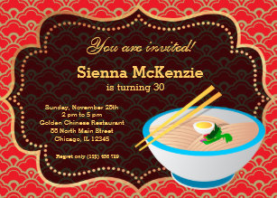  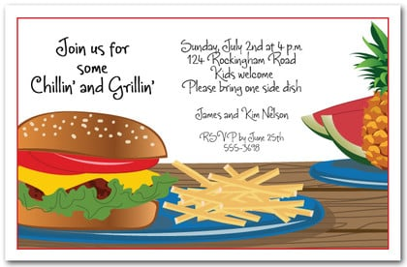

MUSIC | PE | RE
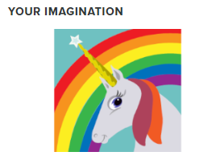  At school, for some of our music lessons, we use a scheme called Charanga. You can now access it at home (home learning site is called Yumu).  Once you are logged in, there are different units for you to try and also a song bank that you can choose songs from.  Click on the link below and enjoy!  https://www.BradfordMusicOnline.co.uk/yumu  The logins for the classes are  Your username is: AS2B  Your password is: Brown  Your username is: AS2M  Your password is: McMurrough | Shimmy, salsa and shake your way to the end of term.  Celebrate all your hard work and super effort this term with a disco at home. Make up your own dance or have a dance along to some of the Just Dance videos by clicking on the links below.  https://www.youtube.com/watch?v=gCzgc_RelBA  https://www.youtube.com/watch?v=RYgIVc5Jvjg  https://www.youtube.com/watch?v=SH7A3NVQbY | Food used in religious Festivals and celebrations.  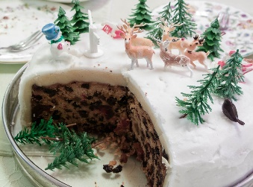  This week we are thinking of food from around the world. In celebrations people eat special foods. Can you think of food which is linked to Christmas?  Also special foods linked to Easter?  Research and find pictures, draw pictures of these foods. Then create a collage picture of foods for Christmas, Easter, birthday parties, weddings etc.  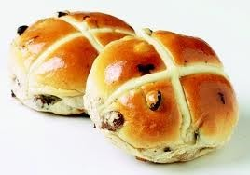  Have fun researching the festivals and foods linked to each. Try find out what different foods there are between countries and each celebration.  Questions  Do all countries have Christmas cake?  Does Italy eat hot cross buns at Easter?  In which country would you find lots of Panetone?

