Year 2 weekly plan W/B 6th July 2020
 | English | Maths
Monday | Spellings – tion  Watch the video clip on tion. There is also a power point to watch  https://www.youtube.com/watch?v=4I4o4WrTLMg  Complete the two worksheets. One is a word search and the other is a crossword. | Lesson 1 - Litres  Watch the white Rose Maths Video on ‘Litres’ (See link) and complete the accompanying activity sheet. You can download the accompanying sheets from our home learning page.  https://vimeo.com/434747843
Tuesday | Alphabetical Order.  When we sort words into alphabetical order, we look at the first letter. Sometimes we may need to look at the second, even third letter if they are the same.  Complete the worksheet on alphabetical order with food words. | Lesson 2 - Temperature  Watch the white Rose Maths Video on ‘Temperature’ (See link) and complete the accompanying activity sheet.  https://vimeo.com/434748010
Wednesday | Using an index and glossary.  Have a look at an information book on food or an encyclopaedia. Where is the index? Does it have a glossary? See the worksheet on “Using an Index and Glossary” that explains what each of these non-fiction features are. Complete the sheet using your information book. If you do not have a book you can click on the link below to find two e books that you can use.  Blue level  https://www.oxfordowl.co.uk/api/interactives/26361.html  Purple level  https://www.oxfordowl.co.uk/api/interactives/12964.html  Challenge  Have a go at creating your own Glossary - watch the link below to help you.  https://www.youtube.com/watch?v=UMxNJiANqJU | Lesson 3 - O'clock and half past  Watch the white Rose Maths Video on ‘O'clock and half past’ (See link) and complete the accompanying activity sheet.  https://vimeo.com/434770979
Thursday | Making a sandwich  Use your theme sheet on designing a sandwich to make one. As you are making it write down what you do at each stage. When it is complete create an instruction sheet for someone else to make your sandwich. Remember to start with an action verb. Chop/Cut/Spread – and use numbers for each instruction. Take a picture of your sandwich and add it. You can also illustrate it as you go along. | Lesson 4 – Quarter past and quarter to  Watch the white Rose Maths Video on ‘Quarter past and quarter to’ (See link) and complete the accompanying activity sheet.  https://vimeo.com/434771282
Friday | Spelling dictation (see download sheet) Read the passage a sentence at a time to your child for them to copy into their blue spelling book. The passage incorporates the weekly spellings and other high frequency words. | Complete the ‘Friday maths challenge’  (Summer term- week 11, lesson 5).  https://whiterosemaths.com/homelearning/year-2/

Theme | Science | DT
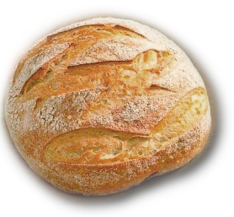  The journey of bread  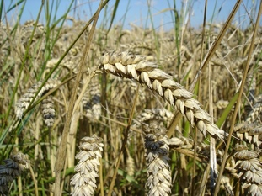  This week you’ll be learning about the journey of bread. Where do you think bread comes from? How do you think it is made?  Look through the PowerPoint ‘The journey of bread’ on our resources page and watch the video here to learn how it is made.  You can choose a way to present what you have learned…. How about making a poster on the computer to show the journey of bread? You could even create a video presentation or have a go at making bread yourself using the recipe on our resources page.  There is also an optional challenge- to find out about different breads from around the world (see worksheet). | Bread experiment- how clean are your hands?  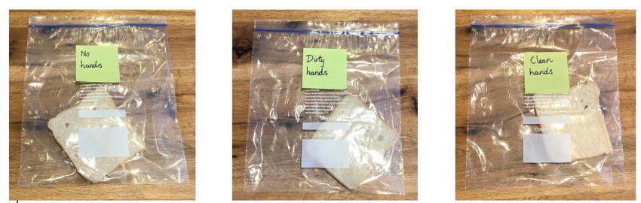  This week in science you will be setting up a simple experiment and observing changes over time (see Science investigation instructions)! Home-made bread works the best, or ones with less preservatives.  Once your experiment is set up, you are now going to observe what happens to your bread over time! Over the next two weeks, look at each bag closely every day. What slice of bread grows mould first? Which grows the most mould? Which grows the least mould? Why do you think that is? Why do you think we should wash our hands regularly? Why is it especially important to wash our hands before touching food?  You can draw a picture of what is happening to the bread every day or keep a photo diary by taking pictures of the bread each day to watch the changes over time. | Sandwich making  In DT you will be making a sandwich of your choice!  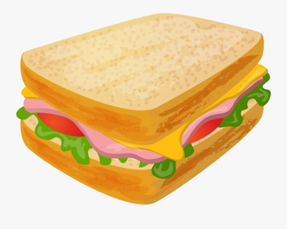  Use the ‘Design a sandwich planning sheet’ to think about what ingredients you will need. Next think about how you are going to make your sandwich. What will you do first? After that? This is important as you’ll be writing instructions for making your sandwich in English this week.  When you make your sandwich, you might even like to take photos of each step so you can remember how you made it.

Music | PE | PSHE
Try these fun music activities at home. Colour each square in when you have completed the task.  (See Resources file to download A4 copy of the grid below.)  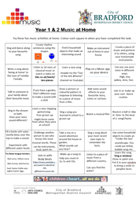 | Our first virtual sports day will run from Monday 6th July- Friday 10th July. I hope you are as excited as we are! (Teachers will be joining in too).  Please refer to the document on our resources page for instructions.  Remember to send your completed form in to 6T@allsaintsilkley.bradford.sch.uk by the end of the week. | What can we do to keep healthy?  This week we are going to access Harold’s Diary again.  Click on the link below to access the resources. Choose one for your child to do.  Harold's Daily Diary  Each day, Harold's diary gets children to think about the different things they need to keep healthy - physically and emotionally. There are ideas for activities, pictures and other resources.

