All Saints’ Virtual Sports Day
Our first ever ‘Virtual Sports Day’ will be taking place for all Year Groups to take part in. The virtual sports day will run from Monday 6th July – Friday 10th July, with each child (and staff member) to complete each challenge.
Each challenge is attached to this letter with instructions of what to do. Also included is a form to complete, with your child's name, year group, house and score. This can then be sent to 6T@allsaintsilkley.bradford.sch.uk
After the five days is up we will be adding the points and will be announcing the results and the winning house of Sports Day 2020. Good Luck!

Name: Year Group: House:
Activity | Bronze | Silver | Gold
Around the world
Burpees
Speed bounce
Star jumps
Catch and clap
High knees
Wall sit of doom
The crab dance
Please e-mail completed forms to: 6T@allsaintsilkley.bradford.sch.uk
Virtual Sports Day challenges

60-second challenge - Around the world

How many times can you pass the ball around your waist in 60 seconds?

If you drop the ball, you need to pick it up and carry on quickly.

Equipment: A ball

Achieve Gold - 50 times around your waist

Achieve Silver - 40 times around your waist

Achieve Bronze - 30 times around your waist

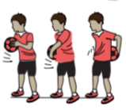

60-second challenge - Burpees

How many burpees can you complete in 60 seconds?

Make sure you extend your legs back once you have lowered yourself to the ground.

Equipment: Just yourself and enough space on the floor and above your head.

Achieve Gold - 30 burpees

Achieve Silver - 20 burpees

Achieve Bronze - 10 burpees

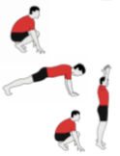

Virtual Sports Day challenges

60-second challenge - Speed bounce

How many times can you bounce over a pillow in 60 seconds?
Both feet must land over the pillow for the jump to count.

Equipment: A pillow. If you do not have a pillow, jump over a safe object.

Achieve Gold - 80 bounces

Achieve Silver - 60 bounces

Achieve Bronze - 40 bounces

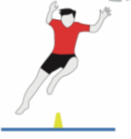

60-second challenge - Star jumps

How many star jumps can you complete in 60 seconds?
Make sure that you clap your hands above your head and bring your feet together.

Equipment: Just yourself and enough space on the floor and above your head.

Achieve Gold - 60 star jumps

Achieve Silver - 45 star jumps

Achieve Bronze - 30 star jumps

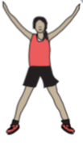

Virtual Sports Day challenges

60-second challenge - Catch and Clap

How many times can you throw a ball up and catch it, in 60 seconds?
The ball must go above your head. If you drop the ball, carry on counting your score from where you left off.

Equipment: A ball. If you do not have a ball, use a toilet roll or pair of socks.

Achieve Gold - 35 catch and claps

Achieve Silver - 25 catch and claps

Achieve Bronze - 15 catch and claps

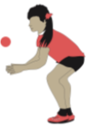

60-second challenge - Bean bag throw

How many times can you throw a beanbag into a hoop in 60 seconds?
Stand three large steps away from the hoop. You need to collect the beanbag and return to the throwing line once thrown.

Equipment: A beanbag and hoop. If you do not have a beanbag or hoop, why not use a pair of socks and a washing basket instead.

Achieve Gold - 30 throws

Achieve Silver - 25 throws

Achieve Bronze - 20 throws

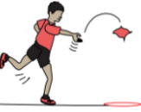

Virtual Sports Day challenges

60-second challenge - Wall-sit of DOOM!

How long can you hold on without falling?
Squat up against a wall keeping your thighs and lower legs at a right-angle from one another. If you stop, the challenge is over and your time is that from when you stopped.

Equipment: A wall that is flat and comfortable to lean against.

Achieve Gold - 60 seconds

Achieve Silver - 40 seconds

Achieve Bronze - 20 seconds
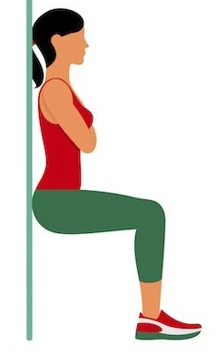

60-second challenge - The Crab Dance

How many times can you run like a crab from one side to another?
Side step (like a crab) from one cone to anther. Your cones should be 5-metres apart and you MUST look silly.

Equipment: Two cones. If you don’t have cones, you could use a t-shirt as a marker. This will be best done outside.

Achieve Gold - 35 catch and claps

Achieve Silver - 25 catch and claps

Achieve Bronze - 15 catch and claps

