W/B 22nd June 2020 Year 1 weekly plan
 | English | Maths
Monday | Phonics focus this week- alternative ‘ou’ sound (see Spelling list 22nd June).  Watch Geraldine the Giraffe introduce this week’s alternative pronunciation. https://www.youtube.com/watch?v=zCbFQN_zVlo. Have a look at this week’s spelling list to learn the other two alternative pronunciations of the ‘ou’ digraph.  Phonics activities to complete during the week:  - Recap the year 1 tricky words- Play ‘Stig's Spelling Adventure’ on Education city.  - Have a go at segmenting and blending the ‘ou’ words using the ‘ou powerpoint’  - Play the ‘ou word sorting game’- sort the words into 4 groups based on what sound the ‘ou’ digraph makes.  - Make some silly sentences using the ‘ou roll and read mat’  Fee Fi Fo Fum, I smell the blood of Key Stage One………  This week in English we are reading the story of Jack and the Beanstalk. We will be using a story from BBC Radio. Every day you can listen to two episodes. There will be some questions for you to answer about each episode (see sheet). There are some writing activity ideas for you to choose from too. To access the episodes, click on the link and scroll down until you see ‘Episode 1 of the story’, watch the video alongside. Then watch episode 2.  https://www.bbc.co.uk/programmes/articles/5qCfgK9MTlHyTP67JgxC2vM/jack-and-the-beanstalk-1-what-shall-we-do | https://whiterosemaths.com/homelearning/year-1/  Watch the white Rose Maths Video on ‘Counting to 100’ (Summer term- week 9, lesson 1) and complete the accompanying activity sheet. You can now download the accompanying sheets from our home learning page.  Challenge ideas: see reasoning & problem-solving PowerPoint
Tuesday | Watch Episode 3 and 4 of the story.  https://www.bbc.co.uk/programmes/articles/1tP3RXkhQ8b6Wv6sHpxYGbt/jack-and-the-beanstalk-2-jack-went-to-the-market | Watch the white Rose Maths Video on ‘Partitioning numbers’ (Summer term- week 9, lesson 2) and complete the accompanying sheet.  Challenge: see PowerPoint
Wednesday | Watch Episode 5 and 6 of the story.  https://www.bbc.co.uk/programmes/articles/3mCJJ17kq4ZyffVjnXcmCwl/jack-and-the-beanstalk-3-and-the-beanstalk-grew | Watch the white Rose Maths Video on ‘Comparing numbers (1)’ (Summer term- week 9, lesson 3) and complete the accompanying sheet.  Challenge: see PowerPoint
Thursday | Watch Episode 7 and 8 of the story.  https://www.bbc.co.uk/programmes/articles/5Q9llc0ZXFYBkFVh8fVdxvk/jack-and-the-beanstalk-4-and-he-went-higher | Watch the white Rose Maths Video on ‘Comparing numbers (2)’ (Summer term- week 9, lesson 4) and complete the accompanying sheet.  Challenge: see PowerPoint
Friday | Watch Episode 9 and 10 of the story.  https://www.bbc.co.uk/programmes/articles/3ZgLjtlm808pzfL5pKmxZ23/jack-and-the-beanstalk-5-fee-fi-fo-fum  Joined handwriting! Watch the video and practise the 3 joins (ci, cr, di) using the ‘handwriting lines’.  Spelling dictation. Read the passage on the spelling sheet a sentence at a time to your child for them to copy into their home spelling book (see Spelling list 22nd June). The passage incorporates the weekly spellings and other high frequency words. | Complete the ‘Friday maths challenge’ (Summer term- week 9, lesson 5).

Theme  (Home/school) | Science  (home) | Art  (Home/school)
The Life cycle of a plant  What is the life cycle of a plant? Watch this video to find out! Discuss some of the new vocabulary you have learned with your family.  https://www.bbc.co.uk/bitesize/clips/z3wsbk7  You are now going to find out about the life cycle of a sunflower!  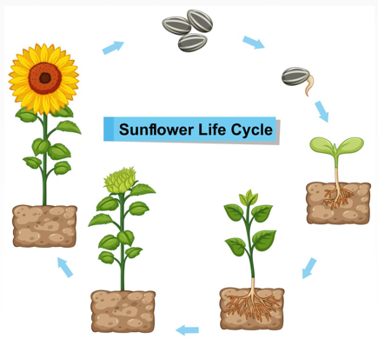  Have a look at the ‘Sunflower life cycle PowerPoint’ on the resources page.  Use the PowerPoint to fill in the ‘Sunflower life cycle worksheet’. Draw a picture in each box to show what happens in each part of the life cycle. | Grow your own beanstalk!  This week we are going to be growing a broad bean seed in a jam jar and keeping a diary to track how our little seeds grows!  If you don’t have a broad bean seed, use some cress seeds or any seeds you have around the house. Watch the video below to find out how to plant your seed.  https://www.youtube.com/watch?v=RTRW2Cf9U2U  Use the ‘Seed diary sheet’ on our resources page to track how your seed grows. You can take photos or draw pictures to show how your seed grows. We can’t wait to see them!  Science challenge- spark some curiosity and ‘big’ thinking with this wonder question.  Discuss this question with your family. How big do you think your bean will grow? Do you think a bigger seed would grow into a bigger plant? Maybe you could plan a way to investigate this question at home. | Jack and the beanstalk  Create your own beanstalk picture or model. You could use pencils, paints, felt tips, crayons, cotton wool, leaves from outside, kitchen roll tubes…. be creative!  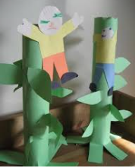  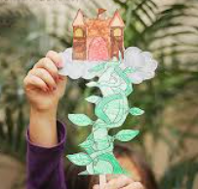  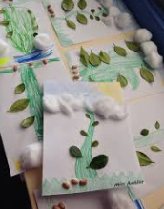  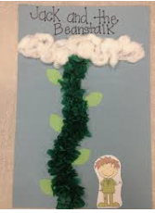

DT  (home) | Music  (home) | PE  (home) | PSHE  (home)
Make your own castle  Build your own ‘Castle in the clouds’ from Jack and the beanstalk.  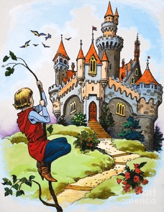  You may want to use Lego, playdough or even junk model materials!  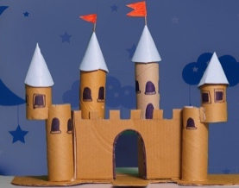  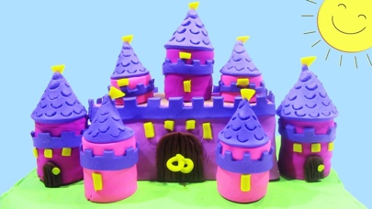  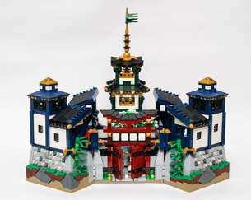 | Performing  This week you’ll be learning to perform the song ‘What shall we do?’ from Jack and the beanstalk.  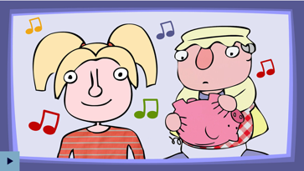  https://www.bbc.co.uk/teach/school-radio/music-jack-and-the-beanstalk-song1/z7m67nb  You can pick whether you’d like to sing part A or part B, or you can sing both parts if you’d like! Once you have learned the chorus and verses 1 to 3, perform the song to your family. You could even record your performance and send it to your class email address. | Jump start Johnny  JUMP START YOUR DAY WITH JSJ!  https://www.jumpstartjonny.co.uk/home  Jump Start Jonny is on a mission to get kids fit! His fun workouts and chill-out videos are loved by over 250,000 Jumpsters in schools and homes worldwide! Get jumping today!  (Some free resources in the Free Stuff section) | What can we do to keep mentally healthy?  Remember Kindness week, when we all tried to do acts of Kindness, well this week I would like you to listen to this video by Kate Middleton HRH and see how acts of kindness not only help others but can also Help your mental wellbeing.  https://www.youtube.com/watch?v=J4ejWRWEd5k  You can also access Harold’s Diary again. Click on the link below to access the resources.  Harold's Daily Diary  Choose one for your child to do.  Each day, Harold's diary gets children to think about the different things they need to keep healthy - physically and emotionally. There are ideas for activities, pictures and other resources.

