W/B 15th June 2020 Year 1 weekly plan
 | English | Maths
Monday | Phonics focus this week- alternative ‘ch’ sound (see Spelling list 15th June).  Watch Geraldine the Giraffe introduce the ‘ch’ digraph that makes the /c/ sound.  https://www.youtube.com/watch?v=Z5NRJHA_DA0. The digraph ‘ch’ can also make a /sh/ sound.  Suggested Phonics activities to complete during the week:  - Play Obb and Bob. Follow link and press ‘phase 5’, ‘revise all phase 5’ https://new.phonicsplay.co.uk/resources/phase/5/picnic-on-pluto  - Look through the ‘PowerPoint- alternative ch’ and sound out the words.  - Go on a sound hunt- stick the ‘Alternative ch word cards’ around the garden or around the house & see how many you can find. Sort them into 3 columns based on what sound the ‘ch’ digraph makes.  - Complete the ‘Alternative ch table’. | https://whiterosemaths.com/homelearning/year-1/  Watch the white Rose Maths Video on ‘Arrays’ (Summer term- week 8, lesson 1) and complete the accompanying activity sheet. You can now download the accompanying sheets from our home learning page.  Challenge ideas: Can you make an array using lego or cereal?  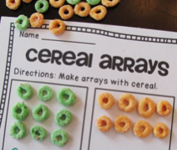  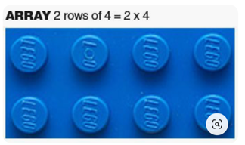
Tuesday | What is a setting?  A setting is a description of where a story takes. When we write about a setting we use lots of describing words to bring the world where our story is happening to life. We need to paint a picture in the reader’s imagination. Read ‘Writing a setting- WAGOLL' from the resources page. Draw detailed picture. Read/ listen carefully to the descriptions so that you include all the detail. Which words help you bring your picture to life? (adjectives) | Watch the white Rose Maths Video on ‘Doubles’ (Summer term- week 8, lesson 2) and complete the accompanying sheet.  Challenge: Roll a dice in front of a mirror- what double did you make?
Wednesday | Adjectives  Read the setting description you used to draw your picture yesterday. Do you remember which words helped you bring your picture to life? Adjectives describe things (e.g. the dark forest). Use a coloured pencil or highlighter to underline some of the adjectives in the setting.  Look at the pictures on the ‘Setting ideas’ sheet. Cut one out and stick it in your home learning book. Write down some adjectives you could use to describe that setting. | Watch the white Rose Maths Video on ‘Sharing’ (Summer term- week 8, lesson 3) and complete the accompanying sheet.  Challenge: See reasoning and problem-solving PowerPoint
Thursday | Write your own setting.  Look at your work on adjectives from yesterday Can you use adjectives that you thought of to write your own setting based on the picture you chose? Look back at the ‘Writing a setting- WAGOLL' you looked at yesterday and the day before, so you know what a good one looks like! Don’t forget to send us your work. You could even send a video of you reading your description of a setting. | Watch the white Rose Maths Video on ‘Grouping’ (Summer term- week 8, lesson 4) and complete the accompanying sheet.  Challenge: See reasoning and problem-solving PowerPoint
Friday | Joined handwriting! Watch the video and practise the 3 joins (can, cap, dam) using the ‘handwriting lines’.  Spelling dictation. Read the passage on the spelling sheet a sentence at a time to your child for them to copy into their home spelling book (see Spelling list 15th June). The passage incorporates the weekly spellings and other high frequency words. | Complete the ‘Friday maths challenge’ (Summer term- week 8, lesson 5).

Theme  (school/home) | Science  (home) | Art  (school/home)
What food do we get from animals?  During a meal time, talk with a grown up about the different types of food you have on your plate. Where do they come from? Do they come from a plant or an animal?  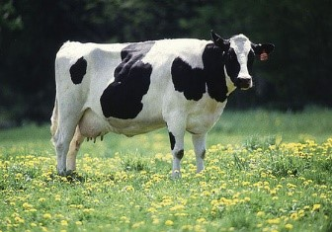  Think about different foods that come from animals.  Look at different animals on the PowerPoint on the resource pages. What food do they give us?  Complete the worksheet ‘Food from animals’. Match the food with the animal it comes from. | Science from cows!  Watch the videos to see how things can change from one thing to another – you can also do the activities yourself to make butter and cream.  https://www.youtube.com/watch?v=Wt_RG42N3GM  https://www.youtube.com/watch?v=3a75ObmDsYM  Try this one  Making plastic toys form milk!!!  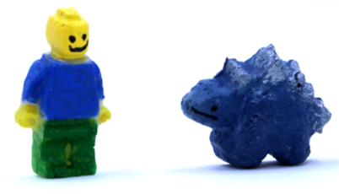  https://www.steampoweredfamily.com/activities/make-plastic-from-milk/  (ignore ads that pop up!!) | Make your own ice-cream picture. Be as creative as you like. Here are some ideas.  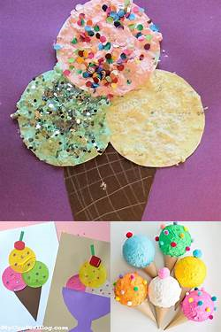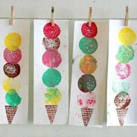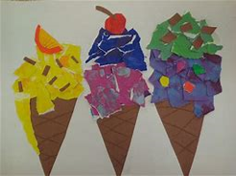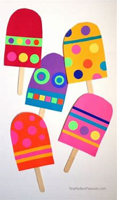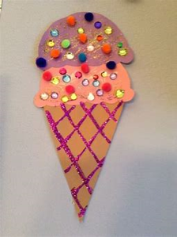

Music  (home) | RE  (home) | DT  (Home)
Try these fun music activities at home. Colour each square in when you have completed the task.  (See Resources file to download A4 copy of the grid below.) | What Objects are special to Sikh’s and why?  Can you remember the 5’s?  Have another look at the Power point to remind yourselves of the 5K’s and what they all mean to Sikhs.  Now you can design your own item and what materials will you use to make it?  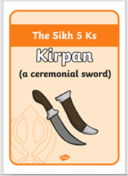  Be creative and think back to the work on materials during the toys topic earlier in the year. Think about materials and their properties.  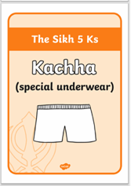  Mum and Dad you can either print out the worksheet or just reproduce boxes in their home learning book. | Have a go at making your very own ice-cream. What flavour will you make? What ingredients do you think you might need? Write a list of ingredients.  You can use one of the recipes below or find your own recipe.  https://www.bbc.co.uk/food/recipes/no-churn_ice_cream_72012  https://www.youtube.com/watch?v=7TiMhu7nDdU  Evaluate what you have done. Did your ice-cream turn out the way you had hoped? Is it delicious? What would you change if you did it again? Don’t forget to email us your pictures!
PE
(home)
Have a go at making your own exercise dice. Use the net template attached and put different exercises on each face of the cube. Roll the dice and try to do each exercise for 30 seconds.

We have done an example to help you with some exercise ideas. You will find the blank nets underneath the example.

Have fun!

