W/B 8th June 2020 Year 1 weekly plan
 | English | Maths
Monday | Phonics focus this week- alternative ‘y’ sound (see Spelling list 8th June).  Watch Mr Thorne introduce the letter ‘y’ that makes the /ee/ sound and the /igh/ sound using the videos below.  https://www.youtube.com/watch?v=t0C01G_sCsQ.  https://www.youtube.com/watch?v=naZWdYBJ70A  The letter ‘y’ can also make an ‘i’ sound in ‘bicycle’.  Suggested Phonics activities to complete during the week:  Look through the alternative ‘y’ PowerPoint and sound out the words.  Fill in the alternative pronunciation for ‘y’ table.  Practise spelling /igh/ words using the letter ‘y’ by playing ‘Manu on Mars’ on Education City. | https://whiterosemaths.com/homelearning/year-1/  Watch the white Rose Maths Video on ‘Count in 2s’ (Summer term- week 7, lesson 1) and complete the accompanying activity sheet. You can now download the accompanying sheets from our home learning page.  Challenge ideas: Complete ‘Deep discoveries’ on Education City.
Tuesday | Pick one of your favourite traditional tales you read last week. Read it again and think about the main characters. Is there a goodie and a baddie? What do they look like? What things do they do in the story that make them good or bad?  Complete the sheet ‘Looking at characters- goodies and baddies’. | Watch the white Rose Maths Video on ‘Count in 5s’ (Summer term- week 7, lesson 2) and complete the accompanying sheet.  Challenge: Complete ‘Deep sea dive’ on Education City.
Wednesday | Today we are focussing on describing characters using adjectives. Remember, adjectives are words that describe a noun. For example, in ‘the wicked witch’- ‘witch’ would be the noun, and ‘wicked’ would be the adjective as it describes what the witch is like. Read through some traditional tales looking carefully at the characters. How are the goodies described? How are the baddies described? Can you think of any more adjectives of your own? Complete the sheet ‘Looking at characters- describing using adjectives’. Have a look at the ‘Fairy tale vocab posters’ and ‘adjectives for describing characters’ on our learning page to help you. | Watch the white Rose Maths Video on ‘Count in 10s’ (Summer term- week 7, lesson 3) and complete the accompanying sheet.  Challenge: You could have a go at some of the problem solving and reasoning challenges in the PowerPoint on our home learning page.
Thursday | You have learned so much about traditional tale characters. Now it is time to create your own! Is your character going to be a goodie or a baddie? What do they look like? What things do they do that make them a good or bad character? How would you describe them? Think back to the adjectives you used yesterday. Use the ‘Create your own character sheet’ to help you. There are some ‘description examples’ on the home learning page to help you. | Watch the white Rose Maths Video on ‘Add equal groups’ (Summer term- week 7, lesson 4) and complete the accompanying sheet.  Challenge: See PowerPoint
Friday | Joined handwriting! Watch the video and practise the 3 joins (ap, ar, aj) using the ‘handwriting lines’.  Spelling dictation. Read the passage on the spelling sheet a sentence at a time to your child for them to copy into their home spelling book (see Spelling list 8th June). The passage incorporates the weekly spellings and other high frequency words. | Complete the ‘Friday maths challenge’ (Summer term- week 7, lesson 5).
As Year 1 are now making a phased return to school, we have separated theme activities into ‘school’ and ‘home’. Children will complete the ‘school’ activities on the two days they are in school and the ‘home’ activities on those days they are at home. Hopefully this way, we can avoid children repeating/missing any of the week’s activities. If you are continuing with home learning, please feel free to complete in whichever order you wish.
Theme  (school) | Science  (school) | DT  (home)
How do plants change through the seasons?  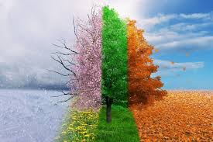  Go on a plant walk! How many different types of plants and trees can you identify?  Look at the PowerPoint ‘All about Summer’. Think back to our plant walks in autumn, winter and spring. How are the plants different now? How have they changed? Why do you think they have changed? You can also watch a video clip on seasonal change here.  Take photographs and write about the changes you have seen in your exercise book. | What are seeds like?  Cut open some fruits (or look at pictures) and look at the seeds. How many are there? What do they look like? Shape? Size? Colour?  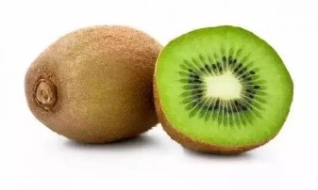  Complete the worksheet ‘Looking at seeds’. Draw your fruit- look carefully at the lines and colours. | Make a fruit salad/kebab!  Decide what fruit you are going to put in your fruit salad- can you make a list of ingredients?  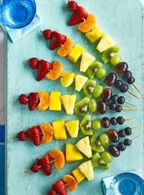  You may even like to make a fruit kebab! Can you make one with a repeating pattern or even a rainbow?  Make your fruit salad or fruit kebab- evaluate it. What went well? Are there any improvements you could make? What would you do differently next time?  Take pictures and send them in to your class email!

Music  (home) | PSHE  (home) | P.E  (school/home)
Try these fun music activities at home. Colour each square in when you have completed the task.  (See Resources file to download A4 copy of the grid below.) | What can we do to keep healthy?  This week we are going to access Harold’s Diary again.  Click on the link below to access the resources. Choose one for your child to do.  Harold's Daily Diary  Each day, Harold's diary gets children to think about the different things they need to keep healthy - physically and emotionally. There are ideas for activities, pictures and other resources. | Make your own scorecard for one of the following activities or choose your own and then ask someone at home to time you for one minute.  Record your score. See how much you can improve by trying the activity five times.  How many star jumps can you do in one minute?  How many times can you throw a ball in the air and catch it in one minute?  How many times can you skip with a rope in one minute?  