W/B 29th June 2020 Year 1 weekly plan
 | English | Maths
Monday | Phonics focus this week- Plurals- words ending in -s or -es (see Spelling list 29th June).  Phonics activities to complete during the week:  - Look at the PowerPoint- ‘Plurals -s and -es’  - Complete the ‘Make it plural worksheet’  - Play ‘Roots to fortune’ on Education city.  - House hunt- how many objects can you find that would end in -s or -es? | https://whiterosemaths.com/homelearning/year-1/  Watch the white Rose Maths Video on ‘Ordering numbers’ (Summer term- week 10, lesson 1) and complete the accompanying activity sheet. You can now download the accompanying sheets from our home learning page.
Tuesday | Fee Fi Fo Fum, I smell the blood of Key Stage One………  This week in English we will finish the story of Jack and the Beanstalk.  https://www.bbc.co.uk/programmes/articles/1mnty92MgRBcWGY4q0NXQ0D/jack-and-the-beanstalk-6-i-am-the-golden-hen | Watch the white Rose Maths Video on ‘Recognising coins’ (Summer term- week 10, lesson 2) and complete the accompanying sheet.  Challenge: See reasoning and problem-solving PowerPoint.
Wednesday | Watch the final part of the story today and answer the questions.  https://www.bbc.co.uk/programmes/articles/3Tcc96gHcGq0b4QHTjTJNNn/jack-and-the-beanstalk-7-were-rich | Watch the white Rose Maths Video on ‘Recognising notes’ (Summer term- week 10, lesson 3) and complete the accompanying sheet.  Challenge: See PowerPoint
Thursday | Today you are going to hear a different version of Jack and the Beanstalk. Listen carefully to the story. Think about the version we have already read. Is there anything the same in both stories? What is different about them? Complete the Venn diagram - I have started you off.  Jack and the Beanstalk and the French Fries https://www.youtube.com/watch?v=gIkorfNvRdc  Now listen to this version – make comparisons between them all.  Jack and the beanstalk – Revolting Rhymes https://www.youtube.com/watch?v=CpAoCUN4toE | Watch the white Rose Maths Video on ‘Counting in coins’ (Summer term- week 10, lesson 4) and complete the accompanying sheet.  Challenge: See PowerPoint
Friday | Joined handwriting! Watch the video and practise the 3 joins (dr, av, aw) using the ‘handwriting lines’.  Spelling dictation. Read the passage on the spelling sheet a sentence at a time to your child for them to copy into their home spelling book (see Spelling list 29th June). The passage incorporates the weekly spellings and other high frequency words.  English. Listen to these versions of Jack and the beanstalk? Which one has been your favourite? Complete the book review sheet saying what was good about it?  Trust me, Jack's Beanstalk Stinks  https://www.youtube.com/watch?v=eSvX6CDgJtQ  It’s Not Jack and the Beanstalk  https://www.youtube.com/watch?v=3EIKejgrEfc | Complete the ‘Friday maths challenge’ (Summer term- week 10, lesson 5).

Theme  (Home/school) | Science  (home) | Art  (Home)
Where does my food come from?  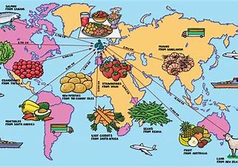  Have a look at some of the labels you find on food in your fridge and in your cupboards. Can you find out where the food has come from? You might have noticed that the fruit you have in your house has often come from different countries. Why do you think that might be?  Can you find out where different fruits have come from? You might be able to find out from looking at the labels on fruits in your home or you might have to do some research on the internet. Complete the activity sheet ‘Where is your fruit from?’ on the resources page. Draw lines to show which country each fruit comes from. | Sweetie Science!  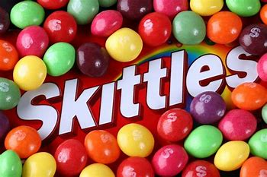  For this week’s science you will need sweets!! Skittles work best for this, but you could have a go with M&Ms too.  Place the Skittles in a circle around a plate, making sure that different colours are next to each other. Fill the centre of the plate with water as shown in the video clip below.  https://www.youtube.com/watch?v=4FHbbc8v1Cs  Carefully observe what is happening. How is the colour moving and changing? Why does this happen? Record your observations on the activity sheet on the resources  https://www.stevespanglerscience.com/lab/experiments/candy-kitchen-science/ | Food faces!  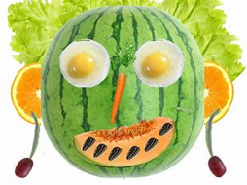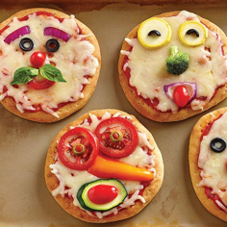  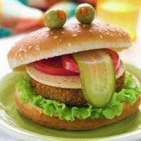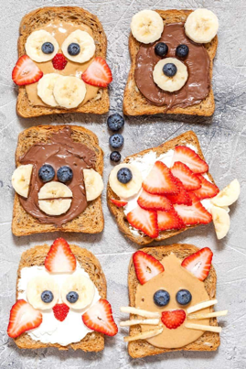  Turn your breakfast, lunch, dinner or snack into a work of art! You can use some of the ideas from the pictures above, search for some ideas on the internet or invent your own. You will need to remember to make your meal a balanced meal by including all of the food groups. Get creative, have fun and don’t forget to send us your photos!

Music  (home) | PE  (home) | RE  (home)
Performing  This week you’ll be learning to perform the song ‘Jack went to market’ from Jack and the beanstalk.  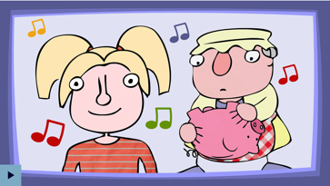  https://www.bbc.co.uk/teach/school-radio/music-jack-and-the-beanstalk-song2/zkhrbdm  - Learn Verse 1 - singing with energy and expression.  - Learn Chorus 1 - reaching up high for those top notes.  - Learn Verses 2 - 5 and Choruses 2 - 5.  Once you have learned the chorus and verses 1 to 5, perform the song to your family. You could even record your performance and send it to your class email address. | At home activity – Cool Catcher  Children at home can have a go at the Cool Catcher session. The activities are easy to do and need very little equipment.  Find the guides attached on the home learning page or click on the link below to watch the video.  https://youtu.be/1pUilVjuL0I | Feeding of the five thousand.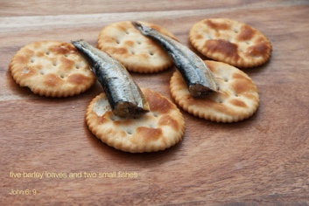  Picture this Jesus in front of thousands with bread and fish, enough to feed his friends only. The story looks at having faith in difficult times. Have you during lock down said a prayer to God for help in difficult times. Do you have faith God will answer.  Watch the story on you tube follow link below;  https://www.youtube.com/watch?v=ngbmQI2sBIo  You can also read and follow the power point on the resources page.  Think about how Jesus’ faith fed so many people on that day and how a simple meal can fill people until they are satisfied.  You can print off the characters and make puppets to retell the story in role play.

