Year 2 weekly plan W/B 22nd June 2020
 | English | Maths
Monday | Spellings – high frequency words - see sheet  Fee Fi Fo Fum, I smell the blood of Key Stage One………  This week in English we are reading the story of Jack and the Beanstalk. We will be using a story from BBC Radio. Every day you can listen to two episodes. There will be some questions for you to answer about each episode (see sheet). There are some writing activity ideas for you to choose from too.  https://www.bbc.co.uk/programmes/articles/5qCfgK9MTlHyTP67JgxC2vM/jack-and-the-beanstalk-1-what-shall-we-do | Describing movement  Watch the white Rose Maths Video on ‘Describing movement’ (See link) and complete the accompanying activity sheet. You can download the accompanying sheets from our home learning page.  https://vimeo.com/430109300
Tuesday | https://www.bbc.co.uk/programmes/articles/1tP3RXkhQ8b6Wv6sHpxYGbt/jack-and-the-beanstalk-2-jack-went-to-the-market | Describing turns  Watch the white Rose Maths Video on ‘Describing turns’ (See link) and complete the accompanying activity sheet.  https://vimeo.com/430109458
Wednesday | https://www.bbc.co.uk/programmes/articles/3mCJJ17kq4ZyffVjnXcmCwl/jack-and-the-beanstalk-3-and-the-beanstalk-grew | Describing movement and turns  Watch the white Rose Maths Video on ‘Describing movement and turns’ (See link) and complete the accompanying activity sheet  https://vimeo.com/430109634
Thursday | https://www.bbc.co.uk/programmes/articles/5Q9llc0ZXFYBkFVh8fVdxvk/jack-and-the-beanstalk-4-and-he-went-higher | Compare Mass  Watch the white Rose Maths Video on ‘Compare Mass’ (See link) and complete the accompanying activity sheet  https://vimeo.com/430109855
Friday | https://www.bbc.co.uk/programmes/articles/3ZgLjtlm808pzfL5pKmxZ23/jack-and-the-beanstalk-5-fee-fi-fo-fum  Spelling dictation (see download sheet) Read the passage a sentence at a time to your child for them to copy into their blue spelling book. The passage incorporates the weekly spellings and other high frequency words. | Complete the ‘Friday maths challenge’ (Summer term- week 9, lesson 5).

Theme | Science | DT | PSHE
The Life cycle of a plant  What is the life cycle of a plant? Watch this video to find out! Discuss some of the new vocabulary you have learned with your family.  https://www.bbc.co.uk/bitesize/clips/z3wsbk7  You are now going to find out about the life cycle of a sunflower!  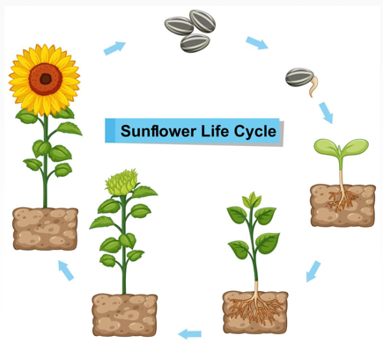  Have a look at the ‘Sunflower life cycle PowerPoint’ on the resources page. Use the PowerPoint to fill in the ‘Sunflower life cycle worksheet’. Draw a picture in each box to show what happens in each part of the life cycle and write a sentence underneath to describe what is happening. | Grow your own beanstalk!  This week we are going to be growing a broad bean seed in a jam jar and keeping a diary to track how our little seeds grows!  If you don’t have a broad bean seed, use some cress seeds or any seeds you have around the house. Watch the video below to find out how to plant your seed.  https://www.youtube.com/watch?v=RTRW2Cf9U2U  Use the ‘Seed diary sheet’ on our resources page to track how your seed grows. You can take photos or draw pictures to show how your seed grows. We can’t wait to see them!  Science challenge- spark some curiosity and ‘big’ thinking with this wonder question. Discuss this question with your family. How big do you think your bean will grow? Do you think a bigger seed would grow into a bigger plant? Maybe you could plan a way to investigate this question at home. | Make your own castle  Build your own ‘Castle in the clouds’ from Jack and the beanstalk.  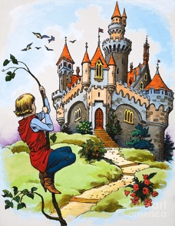  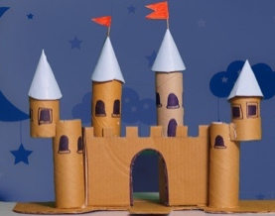  You may want to use Lego, playdough or even junk model materials!  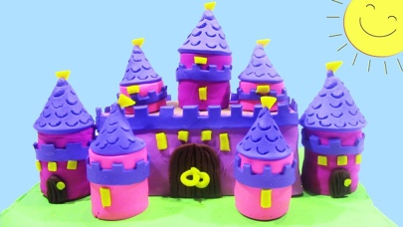  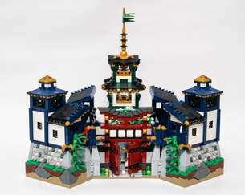 | What can we do to keep healthy?  Remember Kindness week, when we all tried to do acts of Kindness, well this week I would like you to listen to this video by Kate Middleton HRH and see how acts of kindness not only help others but can also Help your mental well being.  https://www.youtube.com/watch?v=J4ejWRWEd5k  We can also access Harold’s Diary again and see what he is up to. Click on the link below to access the resources. Choose one for your child to do.  Harold's Daily Diary  Each day, Harold's diary gets children to think about the different things they need to keep healthy - physically and emotionally. There are ideas for activities, pictures and other resources.

Music | P.E | Art ideas
Performing  This week you’ll be learning to perform the song ‘What shall we do?’ from Jack and the beanstalk.  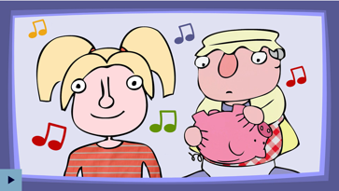  https://www.bbc.co.uk/teach/school-radio/music-jack-and-the-beanstalk-song1/z7m67nb  You can pick whether you’d like to sing part A or part B, or you can sing both parts if you’d like! Once you have learned the chorus and verses 1 to 3, perform the song to your family. You could even record your performance and send it to your class email address. | Jump start Jonny  JUMP START YOUR DAY WITH JSJ!  https://www.jumpstartjonny.co.uk/home  Jump Start Jonny is on a mission to get kids fit! His fun workouts and chill-out videos are loved by over 250,000 Jumpsters in schools and homes worldwide! Get jumping today!  (Some free resources in the Free Stuff section) | Jack and the beanstalk  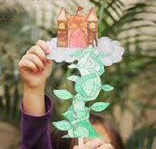  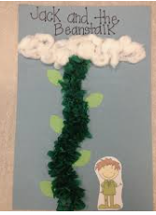  Create your own beanstalk picture or model. You could use pencils, paints, felt tips, crayons, cotton wool, leaves from outside, kitchen roll tubes…. be creative!  