Year 2 weekly plan W/B 8th June 2020
 | English | Maths
Monday | Spellings – Theme words on plants – see spelling sheet | If you click on the link below you will find the alternative lessons for Summer term Week 7.  Watch the white Rose Maths Video and complete the accompanying activity sheet. You can now download the accompanying sheets from our home learning page.  Watch video - Find the total  https://vimeo.com/425620182  Complete Find the total worksheet (lesson 1).
Tuesday | Traditional tales  Look back through the traditional tales from last week – or try some new ones. Look at the characters in the stories. What adjectives are used to describe them? What other adjectives could you use to describe the characters? Complete the worksheet Looking at characters – goodies and baddies – adjectives. | Watch video - Find the difference  https://vimeo.com/425620376  Complete Find the difference worksheet (lesson 2).
Wednesday | Traditional Tales  Look at some of the characters you found yesterday. What makes them a good/bad character? What do they do that is kind/mean? Describe what they look like from the pictures and by using the adjectives found yesterday. Complete the worksheet looking at characters – goodies and baddies. | Watch video - Find change  https://vimeo.com/425620627  Complete Find change worksheet (lesson 3).
Thursday | Traditional Tales  Imagine that you are going to write your own traditional tale. What characters would you have in your story? Choose either the goody or baddy. What do they look like? What things do they do to show they are good or bad? How do they treat others? Read through the examples sheet to give you some ideas. Once you have your ideas down, write the beginning of the story introducing your character. (see creating own character sheet) | Watch video - Two-step problems  https://vimeo.com/425620791  Complete Two step problems worksheet (lesson 4).
Friday | Reading - read the information on parts of a tree and complete the accompanying sheet  Spelling dictation (see download sheet) Read the passage a sentence at a time to your child for them to copy into their blue spelling book. The passage incorporates the weekly spellings and other high frequency words. | Complete the ‘Friday maths challenge’ on the White Rose Maths Hub (Summer term- week 7, lesson 5).  https://whiterosemaths.com/homelearning/year-2/  Alternative challenge: Create your own shop or cafe at home. Make price tags for the items you would like to sell; this could be food or toys. Ask someone from your family if they would come to your shop and buy a few items. You could make receipts to help you work out how much change you need to give back.

Theme | Science | DT | PSHE
What are the parts of a plant?  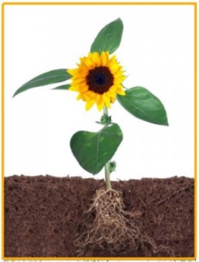  Have a look at the plants in your garden. How many can you name? What do all these plants have in common? What do all plants have?  Watch the power point on the function of the different parts of the plant. Using this information Complete the parts of a plant sheet by labelling the different parts. Write a sentence to show the job that each part has in the life of the plant. | What are seeds like?  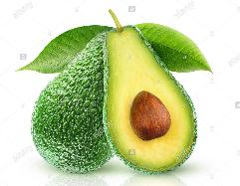  Cut open some fruits (or look at pictures) and look at the seeds. How many are there? What do they look like? Shape? Size? Colour?  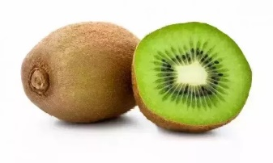  Draw your fruit with the seeds- look carefully at the lines and colours.  Complete seeds sheet | Make a fruit salad/kebab!  Decide what fruit you are going to put in your fruit salad- can you make a list of ingredients?  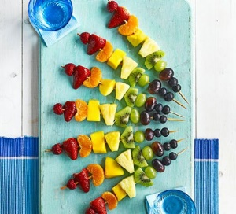  You may even like to make a fruit kebab! Can you make one with a repeating pattern or a rainbow one?  Make your fruit salad or fruit kebab- evaluate it. What went well? Are there any improvements you could make? What would you do differently next time? | What can we do to keep healthy?  This week we are going to access Harold’s Diary again.  Click on the link below to access the resources. Choose one for your child to do.  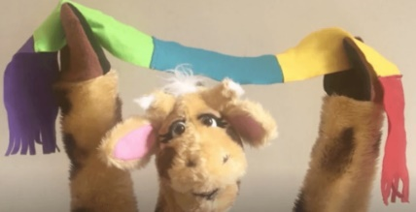  Harold's Daily Diary  Each day, Harold's diary gets children to think about the different things they need to keep healthy - physically and emotionally. There are ideas for activities, pictures and other resources.

Music | P.E
Try these fun music activities at home. Colour each square in when you have completed the task.  (See Resources file to download A4 copy of the grid below.)  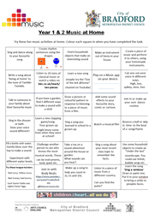 | Make your own scorecard for one of the following activities or choose your own and then ask someone at home to time you for one minute.  Record your score. See how much you can improve by trying the activity five times.  How many star jumps can you do in one minute?  How many times can you throw a ball in the air and catch it in one minute?  How many times can you skip with a rope in one minute?  