Year 2 weekly plan W/B 29th June 2020
 | English | Maths
Monday | Spellings – le/el  Watch nessy video then complete spelling activities.  https://www.youtube.com/watch?v=wvNeBxVuXxI  Handwriting – see sheet | Lesson 1 - Measure mass in grams  Watch the white Rose Maths Video on ‘Measure mass in grams’ (See link) and complete the accompanying activity sheet. You can download the accompanying sheets from our home learning page.  https://vimeo.com/432483400
Tuesday | Fee Fi Fo Fum, I smell the blood of Key Stage One………  This week in English we will finish the story of Jack and the Beanstalk.  https://www.bbc.co.uk/programmes/articles/1mnty92MgRBcWGY4q0NXQ0D/jack-and-the-beanstalk-6-i-am-the-golden-hen | Lesson 2 - Measure mass in kilogram  Watch the white Rose Maths Video on ‘Measure mass in kilogram’ (See link) and complete the accompanying activity sheet.  https://vimeo.com/432483645
Wednesday | Watch the final part of the story today and answer the questions.  https://www.bbc.co.uk/programmes/articles/3Tcc96gHcGq0b4QHTjTJNNn/jack-and-the-beanstalk-7-were-rich | Lesson 3 - Compare volume  Watch the white Rose Maths Video on ‘Compare volume’ (See link) and complete the accompanying activity sheet.https://vimeo.com/432483778
Thursday | Today you are going to hear a different version of Jack and the Beanstalk. Listen carefully to the story. Think about the version we have already read. Is there anything the same in both stories? What is different about them? Complete the Venn diagram - I have started you off.  Jack and the Beanstalk and the French Fries https://www.youtube.com/watch?v=gIkorfNvRdc  Now listen to this version – make comparisons between them all.  Jack and the beanstalk – Revolting Rhymes https://www.youtube.com/watch?v=CpAoCUN4toE | Lesson 4 – Millilitres  Watch the white Rose Maths Video on ‘Millilitres’ (See link) and complete the accompanying activity sheet.  https://vimeo.com/432483882
Friday | Spelling dictation (see download sheet).  Listen to these versions of Jack and the beanstalk? Which one has been your favourite? Complete the book review sheet saying what was good about it?  Trust me, Jack's Beanstalk Stinks  https://www.youtube.com/watch?v=eSvX6CDgJtQ  It’s Not Jack and the Beanstalk  https://www.youtube.com/watch?v=3EIKejgrEfc | Complete the ‘Friday maths challenge’  (Summer term- week 10, lesson 5).  https://whiterosemaths.com/homelearning/year-2/

Theme | Science | Art/ DT | RE
Where does my food come from?  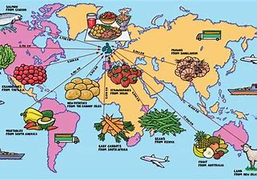  Have a look at some of the labels you find on food in your fridge and in your cupboards. Can you find out where the food has come from? You might have noticed that the fruit you have in your house has often come from different countries. Why do you think that might be?  Can you find out where different fruits have come from? You might be able to find out from looking at the labels on fruits in your home or you might have to do some research on the internet. Complete the activity sheet ‘Where is your fruit from?’ on the resources page. Draw lines to show which country each fruit comes from. | Sweetie Science!  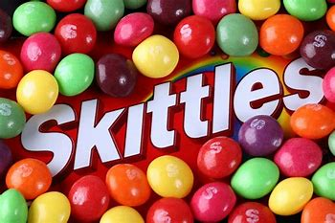  For this week’s science you will need sweets!! Skittles work best for this, but you could have a go with M&Ms too.  Place the Skittles in a circle around a plate, making sure that different colours are next to each other. Fill the centre of the plate with water as shown in the video clip below.  https://www.youtube.com/watch?v=4FHbbc8v1Cs  Carefully observe what is happening. How is the colour moving and changing? Why does this happen? Record your observations on the activity sheet on the resources  https://www.stevespanglerscience.com/lab/experiments/candy-kitchen-science/ | Food faces!  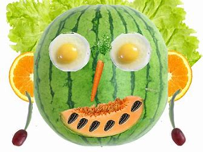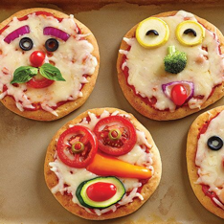  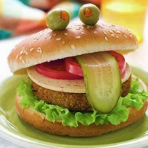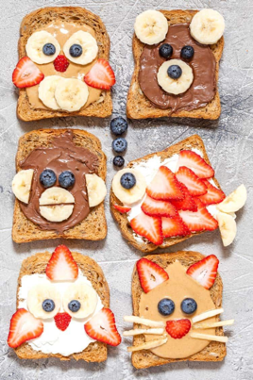  Turn your breakfast, lunch, dinner or snack into a work of art! You can use some of the ideas from the pictures above, search for some ideas on the internet or invent your own. You will need to remember to make your meal a balanced meal by including all of the food groups. Get creative, have fun and don’t forget to send us your photos! | Feeding of the five thousand.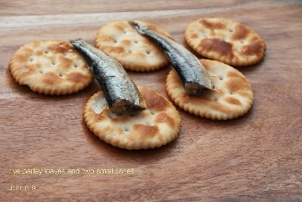  Picture this - Jesus in front of thousands with bread and fish, enough to feed his friends only. The story looks at having faith in difficult times. Have you during lock down said a prayer to God for help in difficult times. Do you have faith God will answer?  Watch the story on you tube follow link below;  https://www.youtube.com/watch?v=ngbmQI2sBIo  You can also read and follow the power point on the resources page.  Think about how Jesus’ faith fed so many people on that day and how a simple meal can fill people until they are satisfied.  You can print off the characters and make puppets to retell the story in role play.

Music | P.E
Performing  This week you’ll be learning to perform the song ‘Jack went to market’ from Jack and the beanstalk.  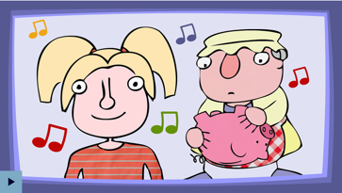  https://www.bbc.co.uk/teach/school-radio/music-jack-and-the-beanstalk-song2/zkhrbdm  - Learn Verse 1 - singing with energy and expression.  - Learn Chorus 1 - reaching up high for those top notes.  - Learn Verses 2 - 5 and Choruses 2 - 5.  Once you have learned the chorus and verses 1 to 5, perform the song to your family. You could even record your performance and send it to your class email address. | At home activity – Cool Catcher  Children at home can have a go at the Cool Catcher session. The activities are easy to do and need very little equipment.  Find the guides attached on the home learning page or click on the link below to watch the video.  https://youtu.be/1pUilVjuL0I

