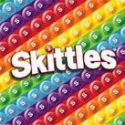
Skittles Experiment.
Draw what the Skittles looked like before and after you added the water.
Before
After

What did you observe?
……………………………………………………………………………………………………………………………………………………………………
……………………………………………………………………………………………………………………………………………………………………

