Lesson 1: What is a symbol?
This week we are starting a new unit and will be working over the next few weeks to answer the unit question: Why are Jewish symbols important to their community?
Task 1: What is a symbol?
Using the grid below, go on a symbol hunt. You could either do this around your home or when out on a walk and see what symbols you can find.
Try to think about 1) what the symbol is for and 2) why you think it was chosen. Use the example below to help
Symbol | Explanation:
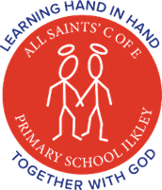 | 1: This symbol is a school logo.  2: I think it was chosen because It shows children holding hands together and the halos represent God. This matches their moto of Learning hand in hand together with God.

Task 2: Why do we use Symbols?
Symbols are there to help identify things. They often give small clues about the thing they represent. For your next task, I would like you to create a symbol for yourself. Think about the things that make you who you are. These could be what you like or dislike, what you are good at or simply something you are passionate about.
The Challenge: Once we have all designs submitted (by the 18th June) I will create a game of ‘Guess Who?’ and post on the home learning page. Remember the symbol needs to give little clues about who you are but not give it away!

Bonus task: If you would like a little extra challenge, I have include a logo quiz. You could have a go yourself or challenge your parents. How many do they know WITHOUT using google!!

