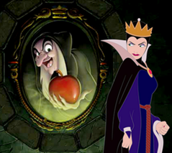
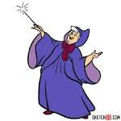
Looking at characters in Traditional Tales
Name of Goody Name of Baddy
_____________ _____________
What do they look like?
_______________________________________________________________________________________________________________________________________________________________________________________________________
___________________________________________________________________________________________________________________________________________________________
What do they look like?
______________________________________________________________________________________________________________________________

What things do they do that make them a bad character?
___________________________________________________________________________________________________________________________________________________________________________________________________________________________________________________________________________
What things do they do that make them a good character?
_____________________________________________________________________________________________________________

Draw the character

Draw the character

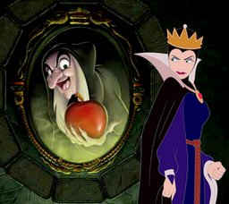
Top of Form

