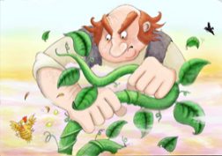
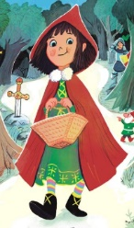
Looking at characters – Goodies and Baddies
Read through some traditional tales looking carefully at the characters. How are they described? Make a list of adjectives you find to describe the characters.
Can you add any more to each box? Use a thesaurus to help you?

Goodies
Baddies
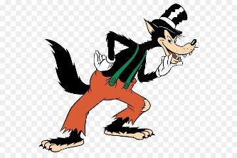
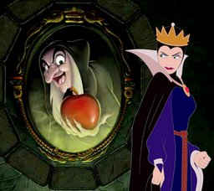
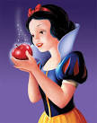
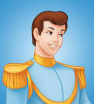

Draw a character from one of the stories and write the adjectives used to describe them. Have a look at the adjective sheet for extra words.

