Lesson 3: Are places of worship symbols?
This week we would have been visiting a Jewish Synagogue in Bradford. So, by the power of the internet we can still have a look but through virtual video.
First, I would like you to think about what we know about a church. Cast you minds back to standing in All Saints’ Church. What do you see around you? What does it feel like being there? What symbols do you see?
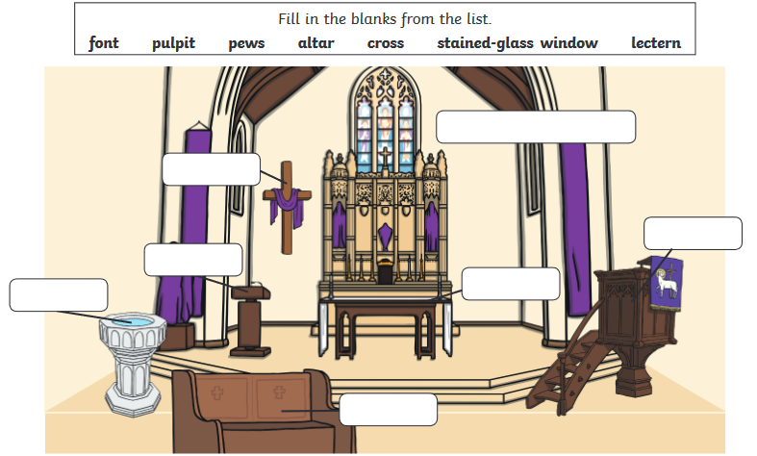

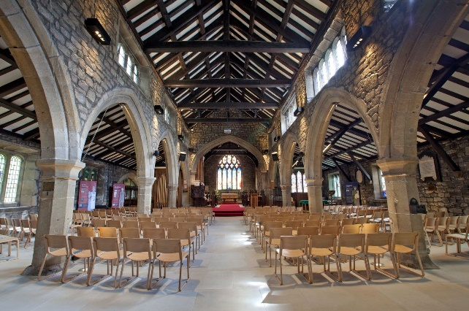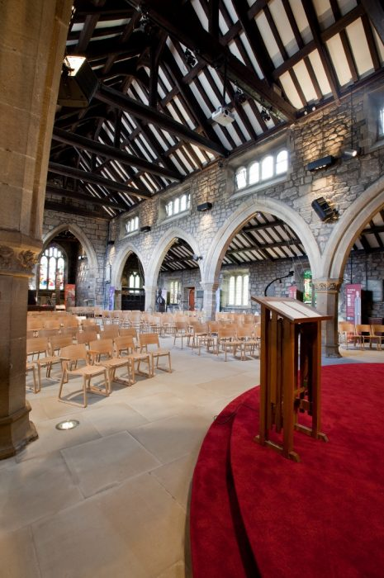

Task 2:
Watch the virtual tour of the Synagogue, can you name the following items? https://www.youtube.com/watch?v=nwPti4ev2VY

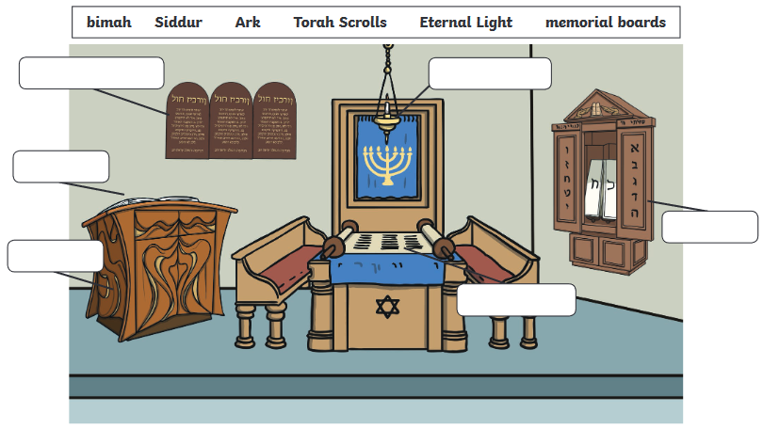
Task 3: Have a look at the PowerPoint on the home learning screen. What do you notice about the different types of Synagogues?
Try to think about our community. Make a spider Diagram to think about in what ways places of Worship might be symbols.
E.G. Seen as a symbol of Hope. A symbol of togetherness.

