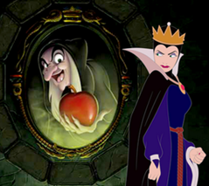
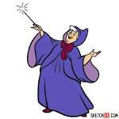
Looking at characters in Traditional Tales
Imagine you are going to write your own Traditional tale. Who are your characters going to be? Think of either a goody or a baddy.
What things do they do that make them a good/bad character? ______________________________________________________________________________________________________________
What do they look like?
_________________________________________________________________________________________________________

Write the beginning of a story to introduce your character. Describe what they look like and also what they do that is mean or friendly. Remember to write in full sentences and use full stops or even exclamation marks!
__________________________________________________________________________________________________________________________________________________________________________________________________________________________________________________________________________________________________________________________________________________________________________________________
Draw your character in a scene at the beginning of a story.

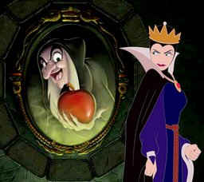
Top of Form

